AN NLP AND DRL APPROACH TO SENTIMENT-BASED

STOCK MARKET ANALYSIS FOR INVESTMENT DECISION

ratish moondra

Final Thesis Report

Master in Data Science - Liverpool John Moores University

May 2024

# Acknowledgement

I would like to thank my esteemed supervisor Ms. Prachi for her invaluable supervision, support and guidance. I would like to express gratitude to her for her treasured support which was really influential in shaping my experiment methods and critiquing my results. I also would like to thank DR. Manoj Jayabalan from Liverpool John Moores University for his continues guidance through the weekly sessions.

I would also like to thank my wife Shalini Moondra, daughter Saanjh Moondra and son Rachit Moondra for their encouragement to let me pursue my academic goals and also ensuring that I stay focussed. Finally, I would like to thank my family and friends for supporting in every way possible which enabled me to complete my research.

Thank you

Ratish Moondra

# Abstract

The stock market, critical for both global and national economies, has experienced significant growth and volatility across the world. It exerts significant influence on economic and decision-making ability of various stakeholder e.g. individual investors, financial analysts, traders, and market practitioners. Consequently, there is a passion on achieving accurate prediction.

Despite great advancements in AI and ML, predicting future stock prices remains challenging but advantageous task at the same time and an area of active research. This study aims to integrate Deep Reinforcement Learning (DRL) and Sentiment Analysis (SA) to create a robust investment decision system. By utilizing NLP techniques and establishing corelation with historical price data, the framework aims to extract textual sentiments and improve investment decisions. This research contributes to enhancing Stock Market Prediction (SMP) methodologies and providing insights for navigating through the modern financial markets. From modelling perspective, the proposed research methodology will infuse Sentiment Analysis (to extract sentiment score i.e. positive, negative or neutral), combine it with Deep neural network (i.e. Long Short-Term Memory) & Unsupervised learning technique (Reinforcement Learning) to understand the hidden data patterns & corelations; thereby maximizing the reward function to help investor makes a right decision and improve profitability and reduce possible losses.

# List Of Tables

Table 3‑1: Stock Price Prediction - LSTM Pros and Cons 37

Table 3‑2: Deep-Q-Network Approach Pros and Cons 38

Table 3‑3: Sentiment Analysis - VADER Pros and Cons 40

Table 3‑4: Sentiment Analysis - SentiWordNet Pros and Cons 41

Table 3‑5: Sentiment Analysis - Deep Neural Network (DNNs) Pros and Cons 41

Table 3‑6: Stock ticker selection 43

Table 3‑7: Stock Price Data 45

Table 3‑8: StockTwits Tweets Data 46

Table 3‑9: Technical indicators 47

Table 4‑1: Data Selection Criteria 52

Table 4‑2: Price statistics at a glance 53

Table 4‑3: Sentiment Statistics 54

Table 4‑4: VADER Model parameters description 63

Table 4‑5: LSTM Model parameters description 66

Table 4‑8: Reward Function 71

Table 4‑6: LSTM Predicted Close Prices (for a period of 5 years) 79

Table 4‑7: LSTM Predicted Close Prices (Analysis Range) 80

Table 4‑9: DRL at action 81

Table A‑1: Price Data for Stock Market Prediction 102

Table A‑2: Tweets or Media Article Data Description 102

Table A‑3: Risk and Contingency Plan 107

# List Of Figures

Figure 3‑1: High-level Flowchart for Research Approach 35

Figure 3‑2: LSTM memory cell 36

Figure 3‑3: Long Short-Term logical architecture 37

Figure 3‑4: Deep-Q-Network architecture 38

Figure 4‑1: Stocks Statistics 53

Figure 4‑2: Price Trend – Close and Open 55

Figure 4‑3: Close price outlier detection 55

Figure 4‑4: Moving Averages tracking Cloe price 56

Figure 4‑5: Daily price movement 58

Figure 4‑6: Stock wise Expected Returns 58

Figure 4‑7: Heatmap for price correlation 59

Figure 4‑8: Sentiment count aggregate 60

Figure 4‑9: Bull to Bear Ratios (Bullish tweet >=50) 60

Figure 4‑10: Monthly tweet comparison 61

Figure 4‑11: Word count aggregate 61

Figure 4‑12: Word count detailed 62

Figure 4‑15: Tuning Lexicon Size 64

Figure 4‑16: Tuning Scoring Thresholds 64

Figure 4‑17: Physical model architecture 65

Figure 4‑18: Hyperparameter Tuning for LSTM Model 68

Figure 4‑19: Physical LSTM model architecture used with RL 69

Figure 4‑20: Buy signal reward function 71

Figure 4‑21: Sell signal reward function 72

Figure 4‑22: Hold signal reward function 72

Figure 4‑13: # of tweets & stock price activity 75

Figure 4‑14: Bull to Bear Ratio and Price Action 76

Figure A‑1: Sentiment Analysis 104

Figure A‑2: Unsupervised Learning (Reinforcement Learning) 105

Figure A‑3: LSTM Network (in conjunction with RL architecture in Figure 2) 105

Figure A‑4: Research Project Plan 107

**List Of Abbreviations**

AI Artificial Intelligence

ATS Automated Trading System

CNN Convolutional Neural Network

DDSS Decadal Diversified Selling Strategy

CR Cumulative Return

DRL Deep Reinforcement Learning

FA Fundamental Analysis

ISI Investment Sentiment Index

LSTM Long Short-Term Memory

MAS Multi Agent System

MER Maximum Error Rate

ML Machine Learning

NLP Natural Language Processing

RNN Recurrent Neural Network

SA Sentiment Analysis

SMP Stock Market Prediction

SVM Support Vector Machine

TA Technical Analysis

VADER Valence Aware Dictionary and sEntiment Reasoner

**Table Of Contents**

Acknowledgement II

Abstract III

List Of Tables IV

List Of Figures V

Chapter 1: Introduction 1

1.1. Background 1

1.2. Problem Statement 2

1.3. Aim and Objectives 3

1.4. Research Questions 3

1.5. Scope of the Study 4

1.6. Significance of the Study 5

1.7. Structure of the Study 5

Chapter 2: Literature Review 8

2.1. Introduction 8

2.2. Machine Learning in Quantitative Finance 8

2.3. Exploring Stock Price Prediction 10

2.4. Deep Learning 11

2.5. Reinforcement Learning 12

2.6. Deep Reinforcement Learning 15

2.7. Researches related to Sentiment Analysis 19

2.8. Combination of SA + Machine Learning Model 23

2.9. Convergence of SA + Deep Learning 24

2.10. Transfer Learning 25

2.11. Multi-Agent Systems and Collective Intelligence Learning 27

2.12. Automated Stock Trading Systems 29

2.13. Summary 31

Chapter 3: Research Methodology 34

3.1. Introduction 34

3.2. Research Approach 34

3.3. Algorithm Selection Rational 35

3.4. Data Collection 43

3.5. Data Source Description 45

3.6. Feature Engineering 46

3.7. Pre-processing 47

3.8. Exploratory Data Analytics (EDA) with Visual Analytics 49

3.9. Model Evaluation 50

Summary 51

Chapter 4: Analysis 52

4.1. Introduction 52

4.2. Data Selection 52

4.3. Data Preprocessing 54

4.4. Feature Engineering 56

4.5. Exploratory Data Analysis (EDA) 57

4.6. Model Building and Tuning 62

4.7. Summary 73

Chapter 5: Results & Discussion 75

5.1. Introduction 75

5.2. Model Evaluation 75

5.3. Model Validation 79

5.4. Research Questions 84

5.5. Required Resources 86

5.6. Summary 86

Chapter 6: Conclusions and Recommendations 88

6.1. Introduction 88

6.2. Discussion & Conclusions 88

6.3. Contribution to knowledge 90

6.4. Future recommendation 90

REFERENCES 91

Appendix-A: Research Proposal 95

# Introduction

## Background

Stock markets serve as a critical foundation for global and national economies, facilitating growth and fostering lucrative investment opportunities. However, their inherent volatility and complex dynamics present significant challenges for investors. Anticipating future stock prices, a field known as Stock Market Prediction, has long captivated academics, researchers, and economists due to its potential to inform better decision-making.

Researchers have explored a wide range of algorithms, from traditional ones like Random Forests and Support Vector Machines to more recent deep neural network-based algorithms. For instance, Zou et al. (2024) demonstrated the efficacy of neural networks, particularly cascaded LSTM frameworks, in deciphering patterns from historical data, resulting in notable improvements in metrics such as Cumulative Return and Maximum Earning Rate.

Despite advancements in the field of Deep Learning, Reinforcement Learning and Sentiment extraction, a key challenge remains, how predictive models react and adapt to unforeseen market events and its sentiments. These events can be influenced by a multitude of factors, including macro and micro-economic trends, sovereign Gross Domestic Product (GDP), market sentiment, companies' growth prospects, consumer prices, central bank policies, and industry-specific nuances in the form of tweets, news articles. Researchers have emphasized the potential of Deep Reinforcement Learning (DRL) agents that combine price prediction with trading signal generation in unsupervised fashion. Furthermore, the fusion of diverse data points, such as Technical Analysis (TA) and Sentiment Analysis (SA), offers a promising avenue for making more informed investment decisions.

This research aims to address the limitations of current methods by proposing a robust decision-making system that integrates DRL and SA. The proposed contributions include:

* Leverage VADER for sentiment extraction in the financial domain
* Combine LSTM networks with Reinforcement Learning to identify patterns and correlations for better trading strategies.
* Explore DRL's ability to process multidimensional data spaces and generate actions without supervision

## Problem Statement

Traditional stock price prediction models struggle to adapt to the dynamic and complex nature of financial markets, hindering investor confidence and their optimal decision-making. The unpredictability of market dynamics, influenced by a myriad of factors including macro and micro-economic trends, poses a formidable challenge to traditional predictive models. This is necessitating innovative methodologies that can effectively integrate diverse data sources and adapt to changing market conditions.

Market efficiency, a foundational concept, refers to the phenomenon where stock prices authentically mirror the information available in the current trading markets. It is essential to recognize that efficiency might not solely stem from new information; rather, they can be influenced by existing data, leading to outcomes that are inherently unpredictable. Efficient predictions are not just advantageous but pivotal, empowering investors with the knowledge needed for astute decision-making.

This research aims to address this challenge by proposing a novel approach that integrates Deep Reinforcement Learning (DRL) and Sentiment Analysis (SA) techniques. By leveraging Natural Language Processing (NLP) for sentiment extraction from textual data such as tweets, and combining it with historical price data, the proposed framework seeks to uncover hidden patterns and correlations using advanced machine learning algorithms, including Long Short-Term Memory (LSTM) networks, Reinforcement Learning (RL) and VADER algorithms. This approach represents a significant advancement in the field of stock price prediction and has the potential to revolutionize investment decision-making processes. However, limitations such as data availability and computational cost will be further explored and addressed.

## Aim and Objectives

The primary aim is to develop a novel model for predicting market moves based on sentiment analysis using NLP and DRL techniques.

Objectives:

* To Analyse existing SA techniques and DRL algorithms applicable to financial markets.
* To Propose an integrated framework that combines NLP for SA and DRL for decision-making in stock trading.
* To Capture and preprocess textual data from social media for sentiment analysis.
* To Evaluate effectiveness (accuracy) of the model in predicting market moves and capturing sentiment-driven fluctuations in stock prices.
* To Interpret patterns and correlations discovered by the model in the stock market dataset.

## Research Questions

Most important question to understand is if fusion of NLP and DRL effectively predict market moves, thereby generating an informed action/decision.

This research aims to address following questions:

1. How can SA be leveraged to extract valuable insights from diverse text sources?
2. How can DRL algorithms be integrated with sentiment analysis to develop decision-making framework for stock trading?
3. To what extent does the fusion of NLP and DRL improve the accuracy of predicting market moves?

## Scope of the Study

### Scope

This study will utilize publicly available data sources, primarily stock prices from YahooFinance and financial tweets from StockTwits. No external surveys or questionnaires will be administered. The research will employ Exploratory Data Analysis (EDA) to uncover correlations between stock price movements and market sentiments expressed on StockTwits. The effectiveness of the developed predictive model will be validated using the combination of data (Price and tweets). Additionally, the study will assess the model's performance concerning the sentiment captured and its impact on trading decisions. The primary focus is on exploring the integration of Deep Reinforcement Learning (DRL) with Sentiment Analysis, specifically using LSTM and RL techniques, to evaluate how this combined model can enhance investor decision-making processes and mitigate potential losses.

### Limitation

It is imperative to recognize the inherent limitations of this study, which may encompass constraints related to data availability, computational resources, and the simplifying assumptions inherent in the model. These limitations will be thoughtfully addressed and delineated within the research findings.

While the primary objective of this study revolves around predicting market actions, there exist avenues for future research to delve into additional dimensions. These may include exploring alternative data sources such as news articles, company earnings reports, and employment data, refining the reward function within Reinforcement Learning, and extending the application of these techniques to encompass cross-market financial assets or classes.

In summary, the scope of this study encompasses the development and assessment of a predictive model for sentiment-based stock market analysis utilizing NLP and DRL techniques. The focal point lies in comprehending the interplay between sentiment and market direction, acknowledging the potential for further exploration and refinement in subsequent research efforts.

## Significance of the Study

Accurately predicting stock prices remains a pivotal challenge in the financial landscape, as inaccuracies can lead to substantial losses. While extensive modelling efforts have been undertaken previously, widespread adoption of effective techniques is yet to be realized. This study makes sincere efforts to bridge this gap by integrating Natural Language Processing (NLP) and Deep Reinforcement Learning (DRL) techniques, thereby pioneering novel methods for extracting insights from textual data and amalgamating them with historical price data to enhance price prediction accuracy.

Moreover, the development of a pioneering predictive model that merges Sentiment Analysis (SA) with DRL represents a paradigm shift in stock market forecasting, optimizing the associated reward function to maximize predictive efficacy.

The implications of this research extend beyond academia, offering tangible benefits to investors, financial analysts, and market practitioners. The ability to accurately forecast market movements based on sentiment analysis and its impact on price dynamics can revolutionize investment decision-making processes, refine trading strategies, and mitigate risks, particularly in volatile market conditions.

The fusion of NLP and DRL techniques constitutes a significant technological advancement in financial analysis. By harnessing the power of machine learning and natural language processing, this study not only pushes the boundaries of computational finance but also unlocks new avenues for comprehending the intricate dynamics of financial markets, thereby empowering stakeholders to make informed and strategic decisions.

## Structure of the Study

Chapter 1: sets the stage by providing a comprehensive overview of the research landscape in stock market prediction. Section 1.1 explores historical context and emphasizes the importance of forecasting in dynamic financial markets. Section 1.2 articulates the problem statement, outlining challenges in predicting stock prices amidst market volatility. Section 1.3 clarifies research objectives, detailing goals to be achieved. Section 1.4 formulates research questions to guide the investigative process. Section 1.5 defines the study's scope, delineating boundaries and parameters. Section 1.6 discusses potential constraints and challenges impacting study outcomes.

Chapter 2: Literature Review undertakes a comprehensive literature review, systematically exploring existing knowledge and research findings pertinent to the study. Section 2.1 introduces machine learning in quantitative finance, while Sections 2.2 and 2.3 delve into advancements in stock price prediction techniques, focusing on the evolution of deep learning and reinforcement learning methodologies. Subsequent sections, 2.4 and 2.5, examine the intricacies of ensemble/hybrid models and artificial neural networks. Sections 2.6 and 2.7 present research in Sentiment Analysis, and Sections 2.8 and 2.9 review hybrids of Sentiment Analysis with machine learning or neural networks, synthesizing key insights from prior studies. Lastly, Section 2.10 onwards discusses advancements in transfer learning, Multi-Agent Systems (MAS), and Automated Trading Systems (ATS).

Chapter 3: elaborates on the research methodology employed in the thesis, detailing the systematic approach to address research questions and achieve objectives. Section 3.1 provides an overview of the methodological framework. Section 3.2 outlines the research approach, covering data collection, preprocessing, analysis, and interpretation steps. Section 3.3 explains rational for Algorithm selection. Section 3.4 and 3.5 describes the dataset used, its composition, structure, and relevance. Section 3.6 discusses data preprocessing techniques, focusing on cleaning, transformation, and standardization. Section 3.7 touches upon exploratory data analysis (EDA) steps to understand dataset characteristics. Section 3.8 covers hyperparameter tuning methods for optimizing model performance and evaluation criteria to assess model performance and validate findings.

Chapter 4: Analysis **Error! Reference source not found.**unfolds the analysis of the research methodology, providing a detailed examination of the data, models, and techniques employed. Section 4.1 offers an overview of the analytical framework. In Section 4.2, the dataset used for analysis is described, including its characteristics and relevance to research objectives. Section 4.3, 4.4 and 4.5 details the analysis, covering data preprocessing, exploratory data analysis, and model selection. Similarly, Section 4.6 lays the ground for the Model development and hyper parameter tuning, exploring the performance of various modelling approaches over time. Section 4.7 draws conclusions drawn from the analysis, synthesizing key findings and insights from the Analysis.

Chapter 5: presents the results and discussion of the study, offering insights into the findings and their implications for research objectives. Section 5.1 provides an overview of model results for the first year of data analysis, highlighting key findings and performance metrics. In Section 5.2, model drift analysis results are discussed, providing insights into the stability and robustness of predictive models over time. Section 5.3 addresses research questions outlined in the study, offering detailed responses based on the analysis. Section 5.4 discusses the resources utilized, including hardware, software, and data sources. Finally, Section 5.5 synthesizes the results and their implications for research objectives, highlighting key findings and their significance within the broader research context.

Chapter 6: concludes the thesis, providing a summary of key findings, implications, and recommendations for future research. Section 6.1 introduces the conclusions chapter, offering an overview of key themes and findings discussed. In Section 6.2, conclusions drawn from the study are synthesized, highlighting key insights and implications gleaned from research findings. Section 6.3 discusses the study's contribution to existing knowledge and its implications for theory, practice, and policy. Finally, Section 6.4 offers recommendations for future research, identifying areas for further investigation and potential avenues for expanding upon the current study.

# Literature Review

## Introduction

In the current rapidly evolving landscape of financial markets, accurate prediction of stock prices and understanding market trends and its relationship with price action is crucial for investors and financial analysts alike. Traditional quantitative models often struggle to capture the complexities of human behaviour and the influence of news and social media on market dynamics. As a result, there has been increasing interest in alternative data sources and advanced analytical techniques such as sentiment analysis and reinforcement learning.

Sentiment analysis, which involves extracting subjective information from textual data, provides valuable insights into investor emotions and opinions. Researcher have tried to develop a methodology for sentiment analysis in tweets related to the various stock market world-vide. Their approach included preprocessing techniques and dimensionality reduction methods, resulting in satisfactory performance in sentiment classification.

Reinforcement learning, on the other hand, offers a framework for learning optimal decision-making strategies through interaction with the environment. Deep reinforcement learning (DRL) algorithms have gained popularity in algorithmic trading, combining price prediction with trading signal production. Researchers are increasingly integrating sentiment analysis with reinforcement learning techniques to develop more accurate and robust models for predicting stock prices and optimizing trading strategies.

The integration of natural language processing (NLP) and deep reinforcement learning techniques in stock market analysis has emerged as a promising approach. This literature review aims to provide a comprehensive understanding of the methodologies, algorithms, and approaches employed in this field. By categorically outlining the diverse landscape of research, this review identifies potential areas for future exploration and highlights the potential of these innovative techniques in revolutionizing stock price prediction and financial modelling.

## Machine Learning in Quantitative Finance

In the realm of quantitative finance, the integration of machine learning techniques has emerged as a powerful tool for predicting market behaviour. The following section provides an overview of recent literature exploring this intersection and identifies potential gaps in current research.

### Existing Literature

(Sahu et al., 2023) compiled a paper titled "An Overview of Machine Learning, Deep Learning, and Reinforcement Learning-Based Techniques in Quantitative Finance: Recent Progress and Challenges". It extensively examined the application of machine learning, deep learning, reinforcement learning, and deep reinforcement learning in quantitative finance. It emphasized the challenges associated with forecasting stock market behaviour, which has garnered considerable interest among economists and computer scientists alike. It reviewed a range of techniques, from traditional linear models to advanced machine learning algorithms, that have been employed in the creation of predictive models for financial markets. Of particular note was the role of machine learning algorithms in extracting high-level patterns from financial market data, enabling more effective anticipation and evaluation of stock and foreign exchange markets. Furthermore, it highlighted the growing adoption of deep learning models by investors looking to leverage artificial intelligence for market analysis. It also discussed the emergence of deep reinforcement learning algorithms in algorithmic trading, which have shown promise in the development of automated trading systems or strategies by incorporating price prediction and trading signal generation.

(Dumiter et al., 2023) delved into the intricate relationship between sentiment indices, technical analysis, and the stock market by highlighting the significance of behavioural economics in understanding market dynamics and the role of sentiment in shaping investor decisions. The research aimed to explore the correlation between sentiment indices, market performance, and the macroeconomic environment. It employed both qualitative and quantitative methodologies, including econometric modelling and graphical analysis, to investigate these connections. Key findings suggest a strong correlation between sentiment indices, technical analysis, and stock market movements, particularly in the US market. The study emphasizes the need to consider sentiment dynamics and technical analysis in investment strategies.

(Hambly et al., 2021) conducted a comprehensive survey titled "Recent Advances in Reinforcement Learning in Finance," which discussed the evolving landscape of reinforcement learning (RL) approaches in the finance industry. The survey highlighted the transformative impact of the increasing volume of financial data on data processing and analysis techniques, leading to new theoretical and computational challenges. It emphasized the advantage of RL over classical stochastic control theory and other analytical approaches, particularly in making optimal decisions in complex financial environments with minimal model assumptions. It provided an overview of RL concepts, including Markov decision processes, and introduced various algorithms, focusing on value-based and policy-based methods that do not heavily rely on model assumptions. Additionally, it explored the integration of neural networks to extend the framework to deep RL algorithms. Furthermore, it the application of RL algorithms in diverse financial decision-making domains such as optimal execution, portfolio optimization, option pricing and hedging, market making, smart order routing, and robo-advising.

### Gaps

While recent research has made significant strides in understanding the influence of investor sentiment on financial markets, several notable gaps persist in the literature. One overarching concern revolves around the reliability and objectivity of measuring market participants' feelings. Instances of market manipulation, censorship, and the influence of news broadcasting entities and social media networks raise questions about the integrity of the data and the potential for biased information dissemination. Additionally, existing research is limited by factors such as restricted time intervals, a focus on single countries, reliance on a single sentiment index.

## Exploring Stock Price Prediction

The accurate prediction of stock prices remains a fundamental challenge within quantitative finance, driving ongoing research efforts aimed at refining modelling techniques to improve forecast accuracy. One particularly promising avenue of investigation involves the application of deep learning models, leveraging technologies such as Long Short-Term Memory (LSTM) networks, Convolutional Neural Networks (CNNs), and transformer-based architectures. However, this subsection explored this space from the foundational level, concentrating on the research conducted using the simplest of ML models within this domain before moving to advanced algorithms.

### Existing Literature

(Tao, 2023) conducted a study titled "Predicting BMW Stock Price Based on Linear Regression, LSTM, and Random Forest Regression," focusing on stock price prediction for BMW, a significant aspect of a country's economy. The author aimed to construct reliable models for predicting BMW's stock price by analysing previous days' stock prices. The study employed three models: Multiple Linear Regression, LSTM, and Random Forest Regression. Utilizing five years of BMW stock price data from Kaggle, the author performed data analysis and modelling, employing various graphical methods to explore the data. The study meticulously checked and demonstrated the feasibility and precision of each model, concluding that the Multiple Linear Regression model exhibited the highest accuracy and lowest mean squared error compared to LSTM and Random Forest Regression models. This discrepancy is evident in the nearly perfect fit observed (R-Squared = 1.00) in the training dataset compared to a lower R-squared (0.87) value in the testing dataset, suggesting potential overfitting.

### Gaps

(Tao, 2023) underscored the inherent challenge of accurately predicting stock market prices, which relies on multiple independent variables. The analysis was constrained by the absence of additional features (such as like oil prices, competitor stock situations, and current economic conditions) beyond basic market data, such as open, high, low, close, adjusted close, and volume.

## Deep Learning

The exploration of deep learning methodologies within the realm of stock price prediction represents a crucial area of inquiry within quantitative finance.

### Existing Literature

(Lawi et al., 2022) explored the implementation of Long Short-Term Memory (LSTM) and Gated Recurrent Units (GRU) on grouped time-series data for accurate stock price prediction in their paper titled "Implementation of Long Short-Term Memory and Gated Recurrent Units on grouped time-series data to predict stock prices accurately." The authors highlighted the dynamic nature of stock price patterns in the capital market and the necessity for accurate data modelling to forecast stock prices with low error rates. They noted the potential of Deep Learning models, particularly LSTM and GRU algorithms, for accurate stock price prediction using time-series data. However, they observed that previous studies on LSTM/GRU implementation had not consistently demonstrated convincing performance results. To address this, the authors proposed eight new architectural models for stock price forecasting by identifying joint movement patterns in the stock market. These models combined LSTM and GRU with four neural network block architectures. The proposed architectural models were evaluated using three accuracy measures: Mean Absolute Percentage Error (MAPE), Root Mean Squared Percentage Error (RMSPE), and Rooted Mean Dimensional Percentage Error (RMDPE), representing lower accuracy, true accuracy, and higher accuracy, respectively, in model usage.

In a separate study, (Kang et al., 2022) proposed a hybrid deep learning model for cryptocurrency price prediction in their study titled "Cryptocurrency Price Prediction with Convolutional Neural Network and Stacked Gated Recurrent Unit." It emphasized the importance of accurate price prediction for optimizing cryptocurrency investments, considering virtual currencies as highly profitable assets. Given the time series nature, they introduced a hybrid model, termed 1-dimensional convolutional neural network and stacked gated recurrent unit (1DCNN-GRU). This hybrid model integrates a 1-dimensional convolutional neural network to encode cryptocurrency price data into a high-level discriminative representation, followed by a stacked gated recurrent unit to capture long-range dependencies of the representation. The proposed 1DCNN-GRU model was evaluated on three different cryptocurrency datasets, including Bitcoin, Ethereum, and Ripple. Experimental results showcased the superior performance of the proposed model, with the lowest Root Mean Squared Error (RMSE) values of 43.933 on the Bitcoin dataset, 3.511 on the Ethereum dataset, and 0.00128 on the Ripple dataset, outperforming existing methods.

### Gaps

The existing literature on deep learning for stock price prediction reveals several gaps that warrant further exploration.

* (Lawi et al., 2022) demonstrated the potential of deep learning models like LSTM and GRU, there is inconsistency in performance across different datasets and methodologies. Additionally, there is a lack of research on the robustness and generalizability of deep learning models in predicting stock prices under varying market conditions and across different financial instruments.
* (Kang et al., 2022)’s study was limited to one week of historical data due to computing resource constraints, which may affect the model’s generalization capability. Additionally, other potential predictive factors like seasonality trends, government policies, and social media were not included.

## Reinforcement Learning

The domain of reinforcement learning (RL) holds significant promise for revolutionizing decision-making processes in dynamic and uncertain environments, particularly within financial markets. RL algorithms learn by interacting with the environment and receiving feedback in the form of rewards, allowing traders to adapt to changing market conditions and optimize trading strategies over time. Recent research (in subsequent sections) have explored various RL techniques, including dynamic ensemble models, multi-agent systems, and transaction-aware RL, demonstrating their effectiveness in automated stock trading and portfolio optimization.

### Existing Literature

The adoption of reinforcement learning techniques in finance marked a paradigm shift in algorithmic trading strategies. Reinforcement learning offers a principled framework for learning optimal decision-making policies through trial and error. Early studies focused on developing reinforcement learning algorithms capable of optimizing trading strategies based on reward signals derived from historical market data.

(Lee et al., 2023) aimed to address the challenge of utilizing historical stock price data in automated stock trading with reinforcement learning (RL), which traditionally does not consider past data due to the Markov property. To overcome this, they introduced the Transformer Actor-Critic with Regularization (TACR) algorithm, which employs a decision transformer to incorporate the correlation of past Markov Decision Process (MDP) elements using an attention network. The TACR algorithm also integrates a critic network for performance enhancement and employs a regularization technique to prevent overestimation of action values. The results demonstrated that TACR outperformed other state-of-the-art methods in terms of the Sharpe ratio and profit, using various stock market datasets, thereby validating the effectiveness of incorporating historical information into RL.

(Yousefi, 2022) conducted a study titled "Deep Reinforcement Learning for Tehran Stock Trading," which was published in the Indonesian Journal of Data and Science. The author emphasized the significance of stock trading as a research area with considerable potential for profit, especially with the advancements in artificial intelligence. Despite the substantial research conducted in the field of prediction and automation trading, the application of deep reinforcement learning (DRL) in stock trading remained an open research area. Yousefi highlighted the suitability of reinforcement learning methods for market trading and presented single stock trading models based on fine-tuned state-of-the-art DRL algorithms, including Deep Deterministic Policy Gradient (DDPG) and Advantage Actor Critic (A2C). These algorithms were designed to interact with the trading market and capture financial market dynamics. The study evaluated the proposed models on historical stock trading data using metrics such as annualized return and Sharpe ratio. The results indicated that the agent designed based on both DDPG and A2C algorithms was capable of making intelligent decisions on historical data, with the DDPG strategy outperforming A2C in terms of convergence, stability, and evaluation criteria.

(Fiorini & Fiorini, 2021) also aimed to explore reinforcement learning (RL) techniques in the domain of stock trading. They conducted an empirical evaluation using real-world stock datasets to assess the viability of RL for making informed trading decisions. The study revealed that RL could be a promising approach for decision-making in stock trading, as evidenced by the performance of their trading algorithm. The algorithm’s Sharpe ratio values were compared with those from other studies, demonstrating that it could achieve comparable results to more complex methods in certain scenarios. This suggests that RL has the potential to simplify the process of stock trading while still providing robust outcomes.

### Gaps

Despite significant advancements, several gaps persist in the literature on reinforcement learning in financial trading. Firstly, there is a need for further research on the generalizability and robustness of RL algorithms across diverse market conditions and financial instruments. Additionally, studies often focus on single-agent RL approaches, overlooking the potential benefits of multi-agent systems for portfolio optimization and risk management. Furthermore, there is limited research on the scalability and computational efficiency of RL algorithms in real-time trading environments.

* (Lee et al., 2023) identified need to analyse external factors under unseen observations. As per them, considering news information embeddings that can affect stock prices and using it as an additional input to the transformer model. This would allow the model to learn external factors as well, which could improve its performance.
* (Yousefi, 2022) demonstrated the effectiveness of DDPG and A2C agents, it primarily focused on Tehran stock data, leaving a gap in understanding the generalizability of findings to other markets. Further investigation into the scalability of DRL algorithms to a larger number of stocks, comparison with traditional trading methods, exploration of real-time applications, and exploration-exploitation trade-offs is warranted.
* While (Fiorini & Fiorini, 2021) demonstrated the potential of reinforcement learning (RL) in stock trading, there is still an opportunity to explore the fusion of RL with sentiment analysis (SA) as highlighted by the other researcher.

Existing literature in the field of financial markets has predominantly focused on comparing the efficacy of reinforcement learning (RL) algorithms. Two primary avenues of exploration have emerged: the utilization of deep Q-networks or policy gradient methods, and the integration of textual sentiment analysis. These approaches aim to enhance decision-making frameworks within financial markets, which are characterized by nonstationarity, posing a formidable challenge for predictive models.

## Deep Reinforcement Learning

In recent years, deep learning techniques have garnered significant attention in the realm of financial markets, particularly in stock market prediction. This surge in interest stems from the capability of deep learning models, such as convolutional neural networks (CNNs), recurrent neural networks (RNNs), and long short-term memory (LSTM) networks, to effectively model complex financial data and extract meaningful patterns. Alongside advancements in deep learning architectures, the integration of sentiment analysis has further enhanced predictive accuracy by leveraging textual data from sources like news articles and social media posts. Despite these advancements, challenges persist in accurately forecasting stock prices due to the dynamic and nonstationary nature of financial markets.

### Existing Literature

(Lin et al., 2023) proposed a deep-reinforcement-learning-based dynamic ensemble model for stock prediction (DRL-DEM) to address the challenges faced by existing ensemble models in dynamically changing stock market environments. The authors highlighted that while deep ensemble models offer adaptability, they often underutilize real-time market feedback and lack adaptability for evolving market conditions. To overcome these limitations, DRL-DEM optimizes the weights of deep-learning-based time-series models using deep reinforcement learning, incorporating real-time investment returns as additional feedback signals for the reinforcement learning algorithm. Moreover, an alternating iterative algorithm is employed to simultaneously train the base predictors and the deep-reinforcement-learning model, enabling coordinated optimization. Experimental results on SSE 50 and NASDAQ 100 datasets demonstrated the effectiveness of DRL-DEM, achieving lower mean square error (MSE), higher Sharpe ratio (SR), and increased cumulative return (CR) compared to recent models. Specifically, the MSE decreased by 21.4% and 28.6%, SR increased by 81.8% and 82.1%, and CR increased by 89.0% and 89.1%, indicating improved forecasting accuracy and stronger investment return capability.

(Awad et al., 2023) conducted a study on stock market prediction using deep reinforcement learning (DRL), highlighting the importance of precise and timely decision-making for ensuring profitable returns in stock market investments. They emphasized the evolution of technology and the introduction of advanced predictive algorithms, reshaping investment strategies. Their study introduced a pioneering approach by integrating artificial neural network (ANN), long short-term memory (LSTM), and natural language processing (NLP) techniques with the deep Q network (DQN) to craft a novel architecture tailored specifically for stock market prediction. This innovative framework harnessed historical stock data, with a focus on gold stocks, and augmented by insightful analysis of social media data from platforms such as S&P, Yahoo, NASDAQ, and various gold market-related channels. The developed model demonstrated predictive prowess by accurately forecasting the opening stock value for the subsequent day, validated across exhaustive datasets. Through rigorous comparative analysis against benchmark algorithms, the research highlighted the unparalleled accuracy and efficacy of the proposed combined algorithmic architecture. Additionally, the study engaged in critical analysis, illuminating the intricate dynamics of the stock market and contributing valuable insights to the realm of stock market predictions.

(Jang & Seong, 2023) investigated the application of deep reinforcement learning for stock portfolio optimization while integrating with modern portfolio theory in their paper titled "Deep reinforcement learning for stock portfolio optimization by connecting with modern portfolio theory." They noted the traditional use of the modern portfolio theory in financial market research for portfolio optimization, but with advancements in artificial intelligence, there is an increasing interest in optimizing portfolios using reinforcement learning techniques. Despite the development of reinforcement learning and deep learning algorithms for portfolio optimization, the securities industry has predominantly relied on the modern portfolio theory. To address this gap, the authors proposed a novel approach that combines modern portfolio theory with deep reinforcement learning, marking the first attempt to integrate recent deep learning technology with traditional financial theory. Specifically, they solved the multimodal problem through the Tucker decomposition of a model incorporating technical analysis and stock return covariates as inputs. The results indicated that their proposed method outperformed state-of-the-art algorithms in terms of the Sharpe ratio, annualized return, and maximum drawdown. Furthermore, the proposed method dynamically adjusted weights according to market trends, distinguishing it from other algorithms. By analysing historical stock data and social media sentiment, they crafted a model capable of forecasting the next day’s opening stock value. Their rigorous comparative analysis against benchmark algorithms demonstrated the superior accuracy and efficacy of their approach, contributing valuable insights into the predictive analytics of stock market dynamics. The study’s innovative fusion of DRL and NLP sets new horizons in the realm of financial predictions.

(Aken et al., 2023) provided a comprehensive overview of the application of Deep Reinforcement Learning (DRL) in stock trading over the past five years, focusing on state definition, action design, reward design, and algorithm selection in DRL-based stock trading models. It highlighted the potential of DRL to enhance stock trading by leveraging the strengths of both Deep Learning (DL) and Reinforcement Learning (RL) to handle large volumes of data and capture nonlinear relationships in highly volatile market conditions. However, challenges such as complex and uncertain market data, market volatility, and information asymmetry impacted the accuracy and stability of DRL models in stock trading. The review identified that continuous optimization of DRL models has led to higher returns and substantial profits in the stock market. However, challenges remained, including the complexity and uncertainty of stock market data, which hampered model training, and the performance gap between training and testing environments.

(Zhang & Lei, 2022) provided a comprehensive overview of the application of Deep Reinforcement Learning (DRL) in stock trading models. They highlighted the integration of the perceptual strength of Deep Learning (DL) with the determination strength of Reinforcement Learning (RL), which has emerged as an advanced approach in stock trading. The review focused on summarizing the research conducted on DRL in stock trading over the past five years, emphasizing state definition, action design, reward design, and algorithm selection in stock trading models. The authors noted that many studies have demonstrated the effectiveness of DRL in improving investment returns and profitability in stock trading. Additionally, they highlighted the increasing adoption of DRL in the stock market and the continuous efforts of researchers to optimize models for achieving higher returns and substantial profits. However, the review also acknowledged the challenges faced by current research on DRL models due to the complexity and uncertainty of stock market data, market volatility, and information asymmetry. They compared the discrepancies in processing logic among various studies, summarized the progress in existing research, and discussed potential improvement directions for DRL models in stock trading.

### Gaps

* (Lin et al., 2023) identified that while the DRL-DEM model shows promising results in combining multiple deep learning-based stock prediction models and dynamically adjusting their weights to enhance adaptability to stock market environments, there is a potential to improve prediction accuracy by incorporating text-based predictors. Additionally, it highlighted the importance of addressing the issue of model time complexity in future research endeavours.
* (Awad et al., 2023) recognized the potential for integrating real-time data streams to enhance the dynamism and responsiveness of predictive systems. Moreover, they aimed to broaden the scope of their algorithm by incorporating additional markets, thus validating the versatility and effectiveness of the model across a wider range of markets and asset classes.
* (Aken et al., 2023) suggested to Investigate the use of multi-module deep reinforcement learning (DRL) structures to enhance prediction in real stock market environments; also to develop a Risk Management strategy within the DRL model to minimize the strategy incompatibility and reduce investment risk.
* (Jang & Seong, 2023) stressed upon the importance to explore the new algorithms that incorporate the advancement in RL; and to investigate a stable and robust reward function that aligns with the financial objectives. Their proposed model during the market downturn needs more investigation that will lead to the adaptability of the model in various market conditions.
* (Zhang & Lei, 2022) highlighted practical implications and limitations of applying proposed prediction methods in real-world trading scenarios, considering factors such as intraday volatility and transaction costs. They also stressed on exploring techniques to enhance the granularity of data used in prediction models, potentially by forecasting stock prices at shorter intervals to capture real-time market dynamics more effectively.

To summarise, the literature review has underscored several key research gaps:

* The need to enhance computational efficiency while maintaining or improving prediction accuracy.
* Addressing the impact of high market volatility and information asymmetry on the performance of deep reinforcement learning algorithms.
* Exploring opportunities to augment the approach with sentiment analysis through the integration of advanced natural language processing techniques or investigating the influence of various sentiment classification models on overall prediction accuracy.

## Researches related to Sentiment Analysis

In the realm of financial sentiment analysis, the historical fascination with the relationship between news sentiment and stock market dynamics has spurred continuous exploration. Initially, researchers relied on rule-based methodologies and sentiment lexicons to interpret textual data from financial reports and news articles. However, the advent of social media platforms ushered in a new era, broadening sentiment analysis to encompass user-generated content. This evolution catalysed the development of more sophisticated techniques, including natural language processing (NLP) and machine learning algorithms trained on labelled sentiment datasets. The emergence of sentiment analysis as a pivotal tool for understanding investor sentiment and its ramifications on financial markets has coincided with the rise of social media. Leveraging advanced NLP techniques, researchers have scrutinized textual data from platforms like Twitter and StockTwits to extract sentiment signals pertinent to stock market trends. Numerous studies have delved into the correlation between social media sentiment and stock price movements, underscoring the potential of sentiment analysis to augment traditional financial forecasting models.

### Existing Literature

(Shahedul Amin et al., 2024) explored the potential of harmonizing macro-financial factors with Twitter sentiment analysis in forecasting stock market trends in their paper titled "Harmonizing Macro-Financial Factors and Twitter Sentiment Analysis in Forecasting Stock Market Trends." They investigated whether sentiment expressed in tweets discussing advancements in artificial intelligence, particularly ChatGPT, could forecast day-to-day fluctuations in stock prices of associated companies. Their analysis involved extracting features such as positive/negative sentiment scores from tweets containing hashtags related to ChatGPT within the timeframe of December 2022 to March 2023, utilizing natural language processing techniques. They employed various classifier machine learning models, including gradient boosting, decision trees, and random forests, to train on tweet sentiments and associated features for predicting stock price movements of key companies like Microsoft and OpenAI. The models underwent training and testing phases using an empirical dataset collected during the specified timeframe. Preliminary findings indicated a plausible correlation between public sentiment reflected in Twitter discussions surrounding ChatGPT and generative AI and subsequent impacts on market valuation and trading activities concerning relevant companies, as measured through stock prices. The study aimed to forecast bullish or bearish trends in the stock market by leveraging sentiment analysis derived from an extensive dataset comprising 500,000 tweets, along with incorporating control variables such as macroeconomic indicators, Twitter uncertainty index, and stock market data for several prominent companies.

(Das et al., 2024) proposed a novel method for enhancing the accuracy of stock price prediction by combining ensemble empirical mode decomposition (EEMD), ensemble convolutional neural network (CNN), and sentiment scores from Twitter (denoted as X) based on historical stock data. The approach utilizes EEMD to decompose the original stock price time series, sentiment analysis data from Twitter, and technical indicator data into intrinsic mode functions (IMFs) and a residual component. An ensemble CNN is then constructed, comprising multiple parallel subnetworks that learn distinct IMF representations to make robust stock price forecasts. Additionally, sentiment scores from Twitter are incorporated through a separate CNN to analyse sentiment in tweets related to target equities. Experimental results demonstrate that the proposed "EEMD-ensemble CNN" model outperforms baseline methods in accurate stock price forecasting, with the inclusion of Twitter sentiment scores contributing to improved forecasts by considering the influence of public sentiment on stock price fluctuations. This study underscores the potential benefits of social media sentiment analysis for financial forecasting and offers practical implications for investors, traders, and financial analysts operating in dynamic stock market environments.

(Divernois & Filipović, 2023) conducted a study titled "StockTwits classified sentiment and stock returns," published in the journal Digital Finance. The authors classified the sentiment of a large sample of StockTwits messages as bullish, bearish, or neutral, and created a stock-aggregate daily sentiment polarity measure. They found that polarity was positively associated with contemporaneous stock returns. However, on average, polarity was not able to predict next-day stock returns. Nonetheless, when conditioning on specific events defined as sudden peaks of message volume, polarity demonstrated predictive power on abnormal returns. Furthermore, the authors used polarity-sorted portfolios to illustrate the economic relevance of their sentiment measure.

(Vicari & Gaspari, 2021) explored the use of natural language processing (NLP) and deep learning (DL) techniques for analysing news sentiments and their potential impact on trading strategies. The authors investigated the effectiveness of DL, particularly Long Short-Term Memory (LSTM) networks, in predicting market sentiment based on news headlines. They utilize the Dow Jones industrial average as a target for sentiment analysis and develop algorithmic trading strategies based on the sentiment predictions derived from daily news headlines spanning from 2008 to 2016, extended up to 2020. Through empirical analysis and real-world scenarios, the authors examine the feasibility and effectiveness of using DL models for sentiment analysis in financial markets.

(Jaggi et al., 2021) conducted a study titled "Text mining of StockTwits data for predicting stock prices," published in the journal Applied System Innovation. They introduced FinALBERT, an ALBERT-based model trained to handle financial domain text classification tasks by labelling StockTwits text data based on stock price change. They collected StockTwits data for over ten years for 25 different companies, including the major five FAANG (Facebook, Amazon, Apple, Netflix, Google) companies, and labelled the datasets using three labelling techniques based on stock price changes. The proposed FinALBERT model was fine-tuned with these labels to achieve optimal results. They experimented with the labelled dataset by training it on traditional machine learning, BERT, and FinBERT models to understand how these labels behaved with different model architectures. They highlighted the competitive advantage of their labelling method, which can effectively analyse historical data, and the mathematical function can be easily customized to predict stock movement.

(Medeiros & Borges, 2020) describe a methodology for analysing sentiments and conducting knowledge discovery in tweets related to the Brazilian stock market. The proposed methodology involves preprocessing and characterizing tweets to obtain an associated vector-space model, followed by dimensionality reduction using Principal Component Analysis and t-Stochastic Neighbor Embedding. Sentiment analysis of stock market tweets is conducted through sentiment classification, topic modelling, and clustering tasks, complemented by a visual analysis process. Experimental results demonstrate satisfactory performances in both single and multi-label sentiment classification scenarios, while the visual analysis process uncovers interesting relationships among topics and clusters.

### Gaps

* (Shahedul Amin et al., 2024)’s study can be extended to integration real-time data streams from various social media platforms and news outlets; employ more advanced NLP techniques, such as transformer-based models; to include cross-market analysis i.e. how sentiment in one market influences another; and a deeper dive into the impact of sentiment on individual stocks, rather than market trends.
* (Das et al., 2024)’s study highlighted the gap to explore to integration with other social networks (such as Instagram, stocktwits); to develop a multistep prediction strategy that forecast stock prices over longer horizons and to explore the application of Graph Neural Networks (GNNs)
* (Divernois & Filipović, 2023) highlighted several research gaps: Firstly, while the study establishes a positive association between daily sentiment polarity and contemporary stock returns, it notes a limitation in predicting stock market movements beyond the immediate term, indicating a need to enhance predictive models for longer-term trends. Secondly, the observation of bias in investor sentiment towards recent past events suggests a gap in understanding and mitigating such biases to improve the accuracy of sentiment analysis. Lastly, while sentiment-sorted portfolios demonstrate economic relevance, there may be limitations or biases in their construction, highlighting a need for robustness checks and exploration of alternative portfolio construction methods to optimize performance.
* (Vicari & Gaspari, 2021) underscored several key directions such as exploring the impact of diverse data sources like social media sentiment, financial reports, or real-time trading data on predictive capabilities. Second, addressing model instability, particularly in contexts involving human discretion, aiming to develop more robust models capable of handling the complexities of human language and behaviour. Lastly, mitigating the risks associated with 'herd behavior' in algorithmic trading, possibly through the incorporation of mechanisms to detect and counteract such behaviours.
* (Jaggi et al., 2021) highlighted the work required for FinALBERT model generalization in diverse financial contexts and its adaptability to different market conditions. Similarly incorporating the real-time data stream handling to assess its performance in live market scenarios and also expanding the financial corpus used for pre-training to include a broader range of financial documents and languages.
* (Medeiros & Borges, 2020)did notexplore the use of DL or DRL in the space of sentiment analysis which could improve accuracy.

## Combination of SA + Machine Learning Model

The integration of sentiment analysis with machine learning models has enabled more comprehensive analyses of financial markets, leveraging both structured and unstructured data sources. By combining sentiment signals extracted from social media with traditional financial indicators, researchers have developed hybrid models capable of capturing the unexplored relationship between investor sentiment and market trends.

### Existing Literature

(Koukaras et al., 2022) explored the application of machine learning (ML) and sentiment analysis (SA) on data from microblogging sites for stock market prediction in their paper titled "Stock Market Prediction Using Microblogging Sentiment Analysis and Machine Learning." The authors developed a model for predicting stock movement by utilizing sentiment analysis on Twitter and StockTwits data. They gathered tweets from these platforms along with financial data from Finance Yahoo, applying SA to the tweets. Seven ML classification models were implemented: K-Nearest Neighbors (KNN), Support Vector Machine (SVM), Logistic Regression (LR), Naïve Bayes (NB), Decision Tree (DT), Random Forest (RF), and Multilayer Perceptron (MLP). The study's novelty lies in integrating multiple SA and ML methods, particularly emphasizing the retrieval of extra features from social media, such as public sentiment, to enhance stock prediction accuracy. The best results were achieved when tweets were analysed using Valence Aware Dictionary and Sentiment Reasoner (VADER) in conjunction with SVM, yielding a top F-score of 76.3% and a top Area Under Curve (AUC) value of 67%.

(Renault, 2020) conducted a study titled "Sentiment analysis and machine learning in finance: a comparison of methods and models on one million messages," published in the journal Digital Finance. The author utilized a large dataset of one million messages from the microblogging platform StockTwits to evaluate the performance of various preprocessing methods and machine learning algorithms for sentiment analysis in finance. The study found that incorporating bigrams and emojis significantly improved sentiment classification performance. However, more complex and time-consuming machine learning methods, such as random forests or neural networks, did not enhance classification accuracy. Additionally, empirical evidence was provided showing that the preprocessing method and dataset size strongly influenced the correlation between investor sentiment and stock returns. Despite a high correlation between investor sentiment and stock returns, the study did not find evidence that sentiment derived from social media messages assisted in predicting the returns of large capitalization stocks at a daily frequency.

### Gaps

* (Koukaras et al., 2022) recognized limitations in accurately interpreting sentiment, especially in social media where sarcasm and nuanced language are common, potentially leading to inaccuracies in training sets. Another point that study acknowledged was the presence of spam accounts, false accounts, and bots in social media data, which can introduce noise and inaccuracies into the dataset, impacting sentiment estimation and model performance. They also emphasized on experimenting with alternative machine learning techniques for sentiment analysis and training data instead of relying solely on pre-packaged libraries could improve sentiment classification accuracy.
* (Renault, 2020) emphasized the critical role of dataset size over preprocessing methods or machine learning algorithms. However, it did not delve into the specific impact of dataset size on sentiment analysis accuracy, potentially leaving a gap in understanding the optimal dataset size required for reliable sentiment indicators. They also highlighted the importance of considering emojis and punctuation in preprocessing textual data from social media, it doesn't explore other preprocessing methods' potential impacts, such as stemming or stopword removal, on sentiment analysis accuracy for short financial texts.

## Convergence of SA + Deep Learning

Researchers explored the integration of sentiment analysis with deep learning models to leverage the predictive power of both approaches. The convergence of sentiment analysis and reinforcement learning holds great promise for enhancing trading strategies in financial markets and Researchers aimed to capitalize on market sentiment dynamics and improve trading performance. These ensembled/hybrid models leveraged the complementary strengths of sentiment analysis and deep learning to adapt to changing market conditions and mitigate risks associated with uncertainty and volatility.

### Existing Literature

(Swathi et al., n.d.) investigated the application of an optimal deep learning-based Long Short-Term Memory (LSTM) model for stock price prediction using Twitter sentiment analysis in their study titled "An optimal deep learning-based LSTM for stock price prediction using twitter sentiment analysis." The authors addressed the significance of sentiment analysis of social media data, particularly Twitter, in predicting future stock prices, considering the influence of economic, social, and political factors on stock market dynamics. They proposed a novel Teaching and Learning Based Optimization (TLBO) model integrated with LSTM-based sentiment analysis to predict stock prices based on Twitter data. The study involved preprocessing Twitter data to remove irrelevant information and transform it into a meaningful format, followed by applying the LSTM model to classify tweets into positive and negative sentiments related to stock prices. To enhance the predictive performance of the LSTM model, the authors utilized the Adam optimizer to determine the learning rate and applied the TLBO model to optimize the output units of the LSTM model. Experimental results demonstrated the superior predictive performance of the TLBO-LSTM model over state-of-the-art methods, achieving a maximum precision of 95.33%, a recall of 85.28%, an F-score of 90%, and an accuracy of 94.73%.

### Gaps

* (Swathi et al., n.d.) demonstrated superior performance on specific Twitter dataset compared to other methods, the study lacked detailed analysis on the model's generalizability across different datasets or market conditions. The study briefly mentioned the processes involved in building the TLBO-LSTM model, such as pre-processing, LSTM-based classification, Adam-based learning rate scheduling, and TLBO-based output unit optimization. However, it failed to provide in-depth explanations or insights into how each component contributes to the model's improved accuracy. Understanding the specific mechanisms behind the model's success could enhance its reproducibility and applicability.

## Transfer Learning

Transfer learning has gained prominence in sentiment analysis, especially in scenarios with limited labelled data. By leveraging pre-trained models and knowledge from related tasks, transfer learning enables the adaptation of sentiment analysis algorithms to specific domains or datasets with minimal supervision. Recent research has investigated the application of transfer learning techniques, such as fine-tuning pre-trained language models, for sentiment analysis in low-resource environments, yielding promising results in predicting stock market sentiments from social media data.

### Existing Literature

(dos Santos Neto et al., 2023) conducted study titled "A survey and study impact of tweet sentiment analysis via transfer learning in low resource scenarios" which explores the application of transfer learning (TL) in sentiment analysis (SA) to address challenges posed by low-resource scenarios where annotated data are scarce. The authors investigate the effectiveness of various language models, including BERT, MultiFiT, ALBERT, and RoBERTa, in sentiment analysis tasks. They demonstrate that these language models outperform traditional models such as CNN and LSTM in sentiment analysis tasks. Additionally, the authors propose a pretrained language model (PTLM) using Twitter data for the MultiFiT and RoBERTa models, achieving competitive results compared to models trained on formal language datasets. The study aims to highlight the impacts of TL and language models, comparing their results with other techniques and discussing the computational costs associated with using these approaches.

(Muhammad et al., 2022) explored the application of a Transformer-based deep learning model for stock price prediction in their paper titled "Transformer-Based Deep Learning Model for Stock Price Prediction: A Case Study on Bangladesh Stock Market." The study addressed the challenge of stock price volatility and unpredictability in modern capital markets, emphasizing the potential for both significant profits and catastrophic financial losses for investors. It introduced the use of the Transformer model, a recently developed machine learning model widely employed in natural language processing and computer vision tasks, for predicting the future prices of stocks listed on the Dhaka Stock Exchange (DSE), the leading stock exchange in Bangladesh. This application of the Transformer model to stock price prediction at the DSE, leveraging time2vec encoding to represent time series features, represented a novel approach. The study focused on predicting the price movement of eight specific stocks listed on the DSE using historical daily and weekly data. The experiments conducted by them demonstrated promising results and acceptable root mean squared error values for most of the stocks, showcasing the potential of Transformer-based models in stock price prediction tasks.

Recent advancements in transfer learning and deep learning have revolutionized sentiment analysis in finance. (Liu et al., 2019) provided an overview of sentiment analysis within the context of transfer learning. They explored the application of transfer learning, a machine learning technique that leverages existing knowledge to address sentiment analysis tasks across different domains. The authors summarized recent research findings in sentiment analysis and focus on algorithms and applications of transfer learning in this field. Their survey aims to highlight the trends and advancements in sentiment analysis, particularly in conjunction with transfer learning techniques.

### Gaps

* (Muhammad et al., 2022)’s research suggested to include broader spectrum of the stocks listed in the DSE to provide insights into its generalizability and robustness in capturing diverse market dynamics. And it also needs to be explored in cross market application i.e. exchanges present worldwide not just Dhaka. Assessing the model's performance in different market contexts shall prove its adaptability and efficacy.

## Multi-Agent Systems and Collective Intelligence Learning

The transition towards multi-agent systems and collective intelligence approaches represents a new frontier in trading. By leveraging collective intelligence, these systems can effectively navigate the complexities of financial markets and achieve superior performance compared to individual trading strategies.

Multi-agent systems (MAS) offer a decentralized approach to decision-making, where multiple autonomous agents interact with each other to achieve collective objectives learning from each other's actions and experiences. In finance, MAS combined with reinforcement learning techniques enable agents to learn optimal trading strategies through interactions with other market participants. Recent research has focused on learning communication protocols among agents to improve coordination and decision-making in multi-order execution tasks. These studies demonstrate the potential of MAS and RL in addressing the challenges of complexity and heterogeneity in financial markets.

### Existing Literature

(Li & Hai, 2024) presented another approach to enhance stock portfolio management through deep reinforcement learning (DRL), aiming to address shortcomings in traditional methods by incorporating stock financial indices and Markowitz mean-variance theory. A three-agent deep reinforcement learning model, Collaborative Multi-agent reinforcement learning-based stock Portfolio management System (CMPS), was devised, leveraging deep Q-networks and self-attention networks to process heterogeneous data including stock quotes and financial indices. Challenges arose in adequately representing complex states beyond real-time stock quotes and balancing risk and return efficiently. However, the model's implementation yielded promising results. CMPS exhibited superior performance compared to state-of-the-art models, with a notable increase in Cumulative Return (CuR), while CMPS-Risk Free (CMPS-RF) demonstrated robust risk management capabilities, achieving the highest annualized Sharpe ratio and Calmar ratio, alongside lower volatility and maximum drawdown. Notably, CMPS showcased adeptness in identifying market bubbles and mitigating associated risks, underscoring its potential in developing efficient investment strategies and advancing portfolio management methodologies.

(Fang et al., 2023) addressed the fundamental task of order execution in quantitative finance by proposing a multi-agent reinforcement learning (MARL) method for optimal multi-order execution, considering practical constraints. They introduced a framework where each agent represents an individual operator responsible for trading a specific order, while also facilitating communication and collaboration among agents to maximize overall profits. Moreover, they proposed a learnable multi-round communication protocol to enhance collaboration among agents by exchanging intended actions and refining them accordingly. Their experiments, conducted on real-world market data, demonstrated superior performance and significantly improved collaboration effectiveness compared to existing methods.

(Canese et al., 2021) conducted a comprehensive review titled "Multi-Agent Reinforcement Learning: A Review of Challenges and Applications" where they analysed various multi-agent reinforcement learning (MARL) algorithms. Beginning with an examination of single-agent reinforcement learning (RL) algorithms, the authors highlighted critical considerations necessary for extending these algorithms to multi-agent scenarios. They categorized the analysed algorithms based on their features and provided a detailed taxonomy of the main MARL approaches found in the literature, elucidating their mathematical models. For each algorithm, the authors discussed potential application fields, along with their respective advantages and disadvantages. Furthermore, (Canese et al., 2021) compared these MARL algorithms based on essential characteristics such as nonstationarity, scalability, and observability, while also discussing common benchmark environments utilized for evaluating their performance.

(Lussange et al., 2021) explored the use of multi-agent reinforcement learning for modelling stock markets in their study titled "Modelling Stock Markets by Multi-agent Reinforcement Learning." The authors addressed the long-standing tradition in quantitative finance of employing a bottom-up approach to infer complex systems using multi-agent systems (MAS), particularly in modelling agents trading via a centralized order book to simulate diverse market phenomena. Previous financial models relied on zero-intelligence agents, limiting the assessment of crucial issues such as agent information and learning, essential for price formation and market activity. To address this limitation, the authors designed a next-generation MAS stock market simulator where each agent learns to trade autonomously via reinforcement learning. They calibrated the model using real market data from the London Stock Exchange from 2007 to 2018 and demonstrated its ability to faithfully reproduce key market microstructure metrics, including various price autocorrelation scalars over multiple time intervals. The incorporation of agent learning enabled accurate emulation of market microstructure as an emergent property of the MAS.

### Gaps

* (Lussange et al., 2021) suggested to conduct experiments and simulations in live or simulated trading environments to better understand the model's effectiveness and its practical utility for financial industry applications. It also highlighted to incorporate psychological traits to a deeper understanding of the interaction between agent learning, cognition, and financial market outcomes.
* (Li & Hai, 2024)’s study introduced a multi-agent DRL model (CMPS) that incorporates financial indices and stock correlations, it can be extended to explore the additional data sources such as global economic indicators, news sentiment analysis, and social media trends to further enhance the predictive accuracy of stock portfolio management. CMPS can be further expanded by using graph neural networks (GNNs) or transformer models to better capture the complex relationships between different financial assets.

## Automated Stock Trading Systems

Automated stock trading systems have gained significant attention in recent years due to advancements in machine learning and artificial intelligence techniques. These systems aim to leverage computational methods to make trading decisions autonomously, potentially offering benefits such as improved efficiency, reduced human bias, and enhanced risk management in financial markets. Deep Reinforcement Learning (DRL) is one such approach that has shown promise in automating stock trading strategies by enabling agents to learn optimal decision-making policies through trial and error.

In this context, researchers have proposed various DRL-based automated stock trading systems to address the challenges posed by financial data, such as low signal-to-noise ratios and unevenness. These systems employ sophisticated neural network architectures, such as Long Short-Term Memory (LSTM) networks, to capture temporal dependencies and hidden patterns in stock market data.

### Existing Literature

(Zou et al., 2024) proposed a novel approach titled "A novel Deep Reinforcement Learning based automated stock trading system using cascaded LSTM networks" in which they addressed the performance challenges faced by Deep Reinforcement Learning (DRL) algorithms when applied to financial data with low signal-to-noise ratios and unevenness. The authors introduced a DRL-based stock trading system leveraging Cascaded Long Short-Term Memory (CLSTM-PPO Model) to capture hidden information in daily stock data. Their model adopted a cascaded structure with two stages of carefully designed deep LSTM networks. The first stage involved extracting time-series features from a sequence of daily stock data using one LSTM, and these features were then fed to the agent in the reinforcement learning algorithm for training, with both the actor and the critic in the agent utilizing LSTM networks. Experimental evaluations conducted on stock market datasets from four major indices demonstrated that the proposed model outperformed several benchmark models across key metrics such as cumulative returns, maximum earning rate, and average profitability per trade. The observed improvements ranged from 5% to 52%, depending on the metric and the stock index, suggesting the promising potential of their method in building an automated stock trading system.

Sun et al. (2023) addressed the challenge of training automated trading agents using reinforcement learning (RL) in the context of quantitative finance, particularly in stock trading. While RL is adept at solving sequential decision-making tasks, such as stock trading, agents equipped with RL models encounter several significant challenges. These challenges include the fact that profit is only realized after executing a sell action, the presence of different profits at the same time step due to varying-length transactions, and the dual nature of the hold action, which deals with empty or nonempty position states. To mitigate these challenges, Sun et al. (2023) introduced a novel trading action termed "wait for the empty position status" and designed appropriate rewards for all actions. This approach, named Transaction-aware Inverse Reinforcement Learning (TAIRL), rewards all trading actions to address reward bias and dilemma. The study evaluated TAIRL through backtesting on 12 stocks across US, UK, and China stock markets, comparing its performance against other state-of-the-art RL methods and moving average trading methods. The experimental results demonstrated that TAIRL achieved state-of-the-art performance in both profitability and anti-risk ability.

### Gaps

* Limited Feature Extraction in Real-time Stock Quotes: Existing studies predominantly utilize real-time stock quotes as training data, which may lead to a probability bias in the state transfer within Markov Decision Processes (MDP) due to insufficient feature extraction. This gap suggests the need for methods that incorporate heterogeneous data sources to improve feature representation and reduce bias in decision-making processes.
* Scalability and Generalization: Many existing models focus on specific datasets or market conditions, raising questions about their scalability and generalization to diverse trading environments. Future research could explore methods for enhancing the scalability and robustness of automated trading systems, enabling them to adapt effectively to different market dynamics and datasets.
* Integration of Risk Management: While some models incorporate risk management principles, such as the introduction of risk-free assets, there remains a gap in the development of comprehensive risk management strategies within automated trading systems. Future work could explore advanced risk management techniques to mitigate downside risk and improve overall portfolio performance.

## Summary

Despite strides in sentiment analysis and reinforcement learning in finance, challenges persist. These include incorporating sentiment with price action, data scarcity, model interpretability, and the robustness of trading strategies in volatile markets. Ethical considerations, such as algorithmic trading and market manipulation, also require further investigation to ensure responsible AI deployment in financial markets. The literature review showcases a breadth of methodologies, with NLP and DRL gaining prominence in stock market analysis. From deep reinforcement learning in trading systems to sentiment analysis-driven predictive models, researchers innovate to extract insights from textual data for informed investment decisions in dynamic financial landscapes.

The exploration of sentiment analysis in finance has evolved significantly from early studies examining news sentiment to the incorporation of social media data, representing a crucial advancement in understanding market dynamics. Initially, researchers relied on rule-based approaches and sentiment lexicons to analyse textual data from financial news articles and reports, as highlighted in studies such as (Vicari & Gaspari, 2021) and (Divernois & Filipović, 2023). However, with the emergence of social media platforms like Twitter and StockTwits, sentiment analysis expanded to encompass unstructured user-generated content, as demonstrated by research like (Das et al., 2024), (Jaggi et al., 2021), and (Renault, 2020). These studies propose innovative methods, such as combining ensemble empirical mode decomposition (EEMD) and convolutional neural networks (CNN) with sentiment scores from Twitter data ((Das et al., 2024)), investigating the predictive power of sentiment polarity derived from StockTwits messages ((Divernois & Filipović, 2023)), and evaluating the performance of various sentiment analysis methods and machine learning algorithms using large datasets from StockTwits ((Renault, 2020)).

The literature review has unveiled numerous avenues for further exploration and improvement within this field. Each subsection above encapsulated distinct themes as mentioned. These categories serve as guideposts list below:

* Data Reliability and Integration: Researcher community highlighted concerns regarding data integrity, such as market manipulation and biased information dissemination. Additionally, some of them emphasized the need to incorporate additional features such as Sentiments beyond basic market data to enhance predictive accuracy.
* Sentiment Analysis and Integration: Researcher community emphasized on the importance of integrating advanced natural language processing techniques to derive the sentiments to augment predictive models for Price action with sentiment analysis.
* Feature Extraction and Model Bias: Researcher community highlighted limitations in accurately interpreting sentiment, especially in social media data, suggesting a need for exploring alternative machine learning techniques for sentiment analysis and training data. Moreover, they emphasized on addressing biases introduced by insufficient feature extraction that incorporate heterogeneous data sources to improve feature representation and reduce bias in decision-making processes.
* Long-term Prediction and Model Adaptability: Researcher community noted limitations in predicting stock market movements beyond the immediate term, indicating a gap in developing predictive models for longer-term trends.
* Model Performance and Generalizability: Researcher community highlighted the inconsistencies in model performance across different datasets and methodologies, indicating a need for its robustness and generalizability of predictive models under varying market conditions and financial instruments.
* Computational Efficiency and Scalability: Researcher community have prompted for addressing the need for enhancing computational efficiency while not putting prediction accuracy at risk.
* Model Interpretability and Explanation: Researcher community emphasized on the importance of understanding the mechanisms behind model success to enhance reproducibility and applicability, indicating a gap in providing in-depth explanations or insights into model performance.

To sum up, research into stock market prediction and sentiment analysis is rapidly evolving, driven by advancements in machine learning techniques. The integration of social media data, sentiment analysis, and sophisticated deep learning architectures is increasingly common, enhancing prediction accuracy and shedding light on market dynamics. The reviewed studies underscore the potential of these approaches in tackling the intricacies of stock market prediction and portfolio optimization, setting the stage for further exploration in this domain.

In essence, the integration of cutting-edge technologies such as deep learning, reinforcement learning, and sentiment analysis offers great potential in revolutionizing stock price prediction and financial modelling. These innovative approaches not only enhance forecast accuracy but also provide valuable insights into market dynamics, empowering investors and financial analysts to make well-informed decisions in today's fast-paced financial landscape.

# Research Methodology

## Introduction

This chapter embarks on a journey to explore diverse approaches aimed at fulfilling our research objectives. Our primary focus lies in investigating the intricate relationship between stock price movement and the sentiment expressed within Stocktwits tweets. In an era dominated by the pervasive influence of social media platforms like Stocktwits, where real-time opinions abound, discerning the impact of sentiment on financial markets emerges as a critical juncture. This chapter serves as a roadmap, delineating our exploration of various sentiment analysis techniques, unsupervised learning with neural networks, and the strategic decisions guiding our implementation choices. Through a nuanced examination of these methodologies, it endeavours to shed light on the dynamic interplay between social media sentiment and stock market dynamics.

## Research Approach

The research methodology (as depicted in Figure 3‑1: High-level Flowchart for Research Approach below) adopted in this study follows a structured and systematic approach, commencing with the careful selection and acquisition of pertinent data sources; followed by preprocessing steps while ensuring its quality and suitability for subsequent analysis. VADER sentiment analysis algorithm is chosen based on its proven success rate in social media to decipher sentiment from stock-related tweets. Similarly, the decision to employ LSTM-based RL algorithms is driven by their adeptness in learning from sequential data, which is able to understand the dynamic behaviour of stock prices properly.

Furthermore, data transformation techniques are implemented to prepare the data for analysis, while EDA (Exploratory Data Analysis) aids in the exploration and visualization of relevant patterns and discern hidden trends. The utilization of EDA methodologies facilitates the extraction of actionable insights, culminating in model evaluation using metrics such as portfolio value to gauge the performance and efficacy of the proposed approach.

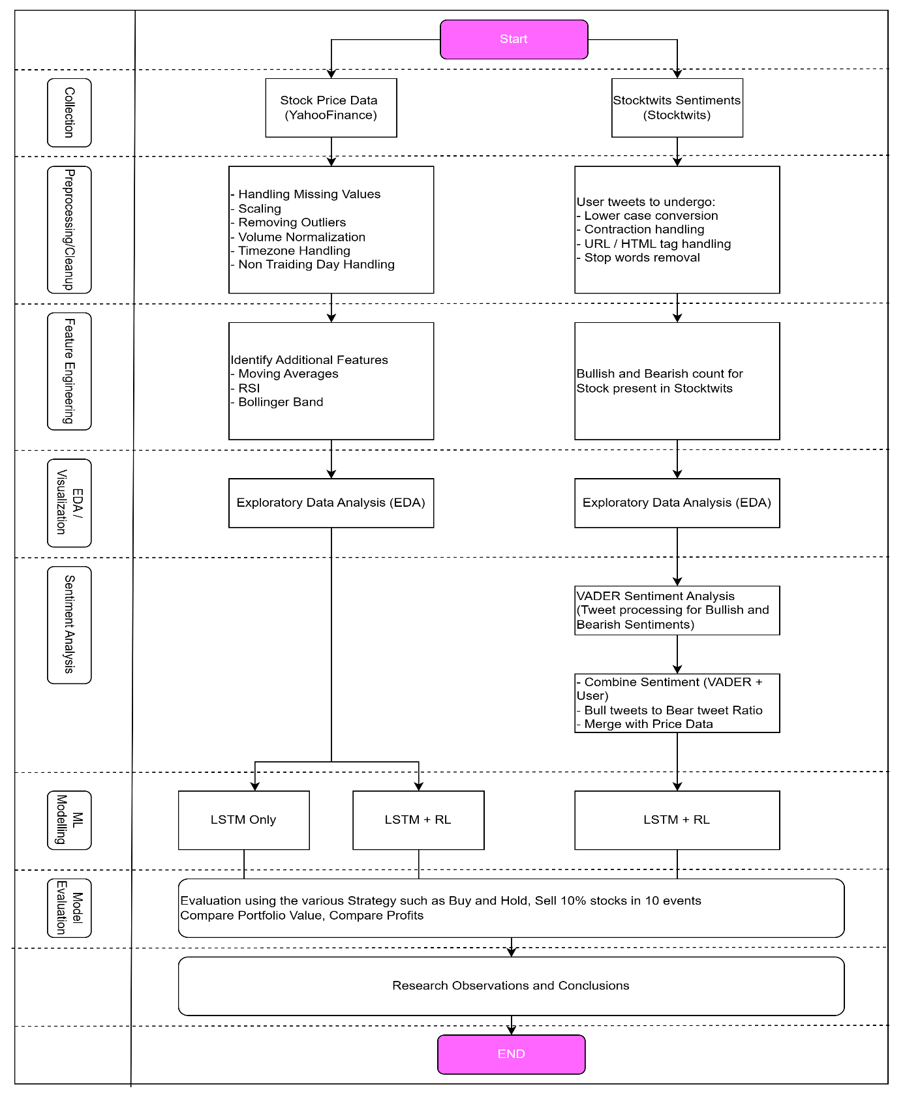Figure 3‑1: High-level Flowchart for Research Approach

## Algorithm Selection Rational

In this phase, several machine learning algorithms were extensively studied, reviewed, as mentioned in Chapter 2: Literature Review for both price predictions/trading signal and sentiment identification.

### Price/Trading signal related algorithms

#### LSTM – Long Short-Term Memory

LSTM is a type of recurrent neural network (RNN) architecture that is particularly well-suited for sequential data processing tasks, such as time series forecasting, natural language processing, and speech recognition. The training algorithm plays a pivotal role in optimizing the parameters of the LSTM network to effectively capture temporal dependencies and patterns within the input sequences.

Unlike traditional RNNs, which suffer from the vanishing gradient problem and struggle to capture long-range dependencies in sequential data, LSTM networks incorporate specialized memory cells and gating mechanisms to address these challenges. The core components of an LSTM unit (as illustrated in **Error! Reference source not found.**) include the input gate, forget gate, cell state, and output gate, each of which regulates the flow of information through the network and facilitates the retention or discard of relevant temporal information.

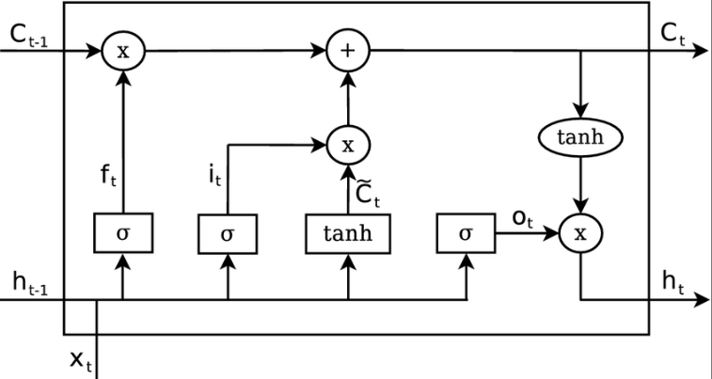

Figure 3‑2: LSTM memory cell

The training of LSTM Network (as depicted in Figure 3‑3: Long Short-Term logical architecture ) typically involves the application of the Backpropagation Through Time (BPTT) algorithm. BPTT extends the backpropagation algorithm to recurrent neural networks, allowing gradients to be propagated through time across multiple time steps. During training, the input sequences are fed into the LSTM network, and the model's predictions are compared against the ground truth labels using a suitable loss function, such as categorical cross-entropy for classification tasks or mean squared error for regression tasks. The gradients of the loss function with respect to the model parameters are then computed using backpropagation, and the model weights are updated accordingly using an optimization algorithm, such as stochastic gradient descent (SGD) or its variants (e.g., Adam, RMSprop).

**Architecture:**

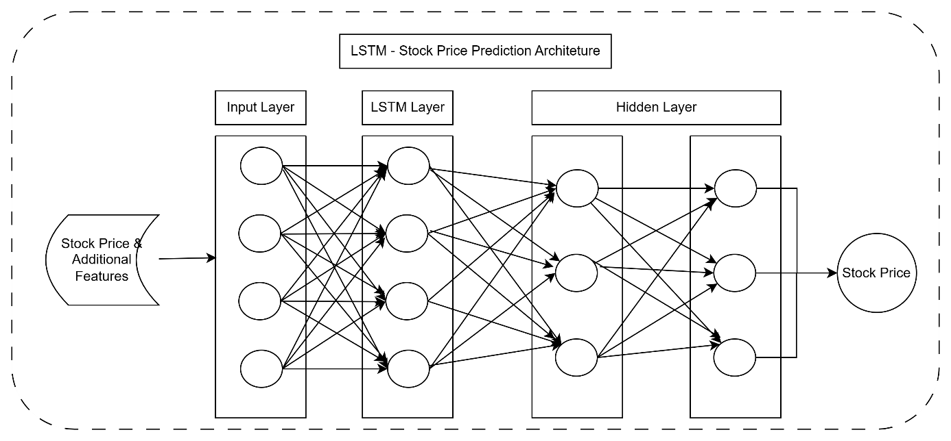

Figure 3‑3: Long Short-Term logical architecture

Table 3‑1: Stock Price Prediction - LSTM Pros and Cons

|  |  |
| --- | --- |
| Pros | Cons |
| Sequential Modelling: LSTM is well-suited for sequential data like time series, making it effective for capturing temporal dependencies in stock price data. | Limited Context: LSTM models might struggle with capturing long-term dependencies in data, especially when the market dynamics change abruptly. |
| Non-linear Patterns: It can capture non-linear patterns in the data, which are common in financial time series. | Overfitting: There's a risk of overfitting, particularly when the dataset is small, which can lead to poor generalization on unseen data. |
| Feature Extraction: LSTM can automatically extract features from the raw data, reducing the need for manual feature engineering. | Lack of Adaptability: LSTM models might not adapt to changing market conditions or sudden events since they rely solely on historical data. |
| Interpretability: The model can be relatively interpretable, allowing analysts to understand how past information influences future predictions. |  |

#### Deep-Q-Network

##### Overview of LSTM and RL Integration

In the realm of reinforcement learning, the integration of Long Short-Term Memory (LSTM) networks presents a compelling architecture for addressing sequential decision-making tasks with complex temporal dependencies. Leveraging the power of LSTM in deep reinforcement learning frameworks enables agents to effectively model and exploit temporal structures inherent in the environment. By incorporating LSTM layers into the architecture, agents can retain memory of past observations and actions, allowing them to make informed decisions based on historical context. This capability proves invaluable in scenarios where immediate actions have long-term consequences, such as financial market trading.

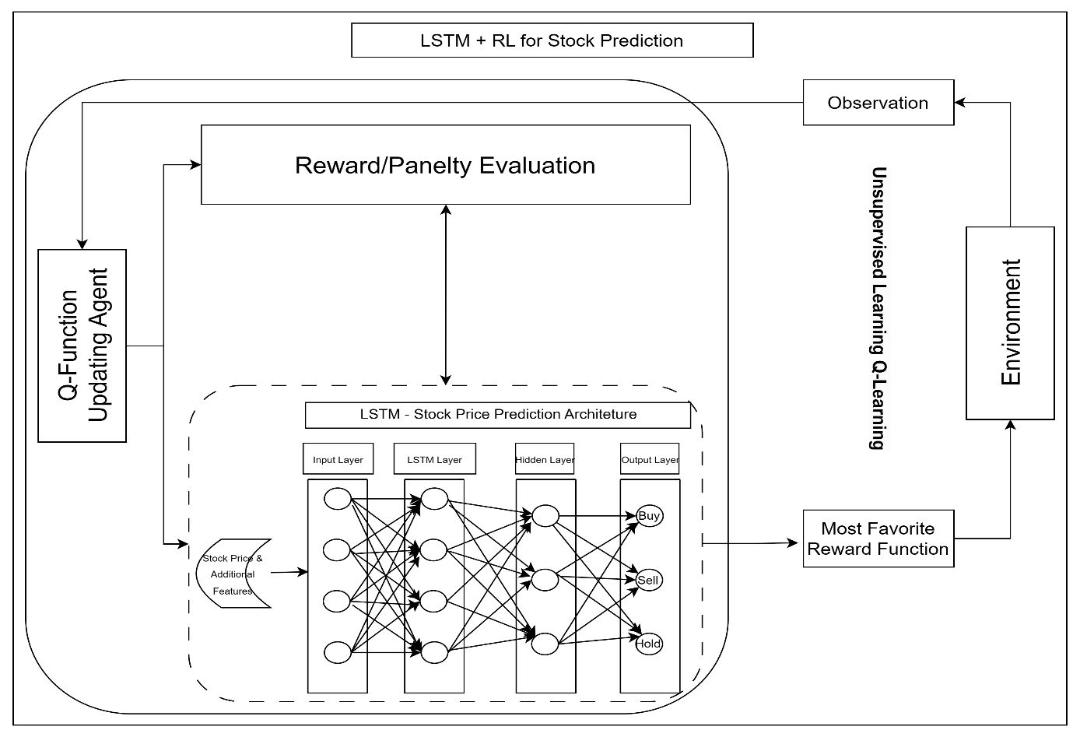

Figure 3‑4: Deep-Q-Network architecture

Table 3‑2: Deep-Q-Network Approach Pros and Cons

|  |  |
| --- | --- |
| Pros | Cons |
| Adaptability: RL algorithms can learn adaptive trading strategies by interacting with the environment, allowing the model to adjust to changing market conditions. | Complexity: Combining LSTM with RL increases the complexity of the model, requiring expertise in both deep learning and reinforcement learning techniques. |
| Dynamic Portfolio Management: RL can optimize portfolio allocation based on current market conditions, maximizing returns and minimizing risks. | Data Efficiency: RL algorithms typically require a large amount of data and extensive training, which might not be feasible in financial markets due to limited historical data and high volatility. |
| Exploration-Exploitation Balance: RL algorithms can strike a balance between exploration (trying out new strategies) and exploitation (leveraging known profitable strategies), which is crucial in dynamic markets. | Computational Resources: RL algorithms can be computationally intensive, requiring substantial computational resources for training and inference. |
| Risk Management: RL can incorporate risk management strategies into the decision-making process, helping to mitigate potential losses. | Black Box Nature: RL models can be less interpretable compared to traditional statistical models, making it challenging to understand the reasoning behind specific trading decisions. |

##### Deep Q-Network

The Deep Q-Network (DQN) is a pioneering reinforcement learning algorithm that combines deep neural networks with Q-learning, a classic reinforcement learning technique. At its core, DQN aims to approximate the optimal action-value function, Q(s, a), which represents the expected cumulative reward of taking action 'a' in state 's'. Unlike traditional Q-learning, which operates on tabular representations of state-action pairs, DQN leverages deep neural networks to approximate the Q-function for high-dimensional input spaces such as stock prices.

The architecture of a DQN typically consists of several layers of convolutional neural networks (CNNs) followed by fully connected layers (as depicted in Figure 3‑4: Deep-Q-Network architecture). The CNN layers extract hierarchical features from raw input observations. These features are then fed into fully connected layers, which learn to approximate the Q-function. The output layer of the network represents the estimated Q-values for each possible action. During training, the DQN minimizes the temporal difference (TD) error between the predicted Q-values and the target Q-values, computed using a target network or a fixed Q-target approach to stabilize training. This process enables the DQN to learn effective action-selection policies through interaction with the environment, leading to improved decision-making in sequential decision tasks.

This research will leverage LSTM individually and also in combination with Deep-Q-Network of Reinforcement Learning for analysis offering advantages in adaptability, dynamic portfolio management, exploration-exploitation balance, and risk management, which suits the research objectives.

### Sentiment Prediction Algorithms

Considering the research objectives of establishing the relationship between the stock prices and market sentiment, various sentiment analysis algorithms were considered such as VADER, SentiWordNet, and Deep Neural Networks (DNNs) for social media sentiments.

#### VADER

Table 3‑3: Sentiment Analysis - VADER Pros and Cons

|  |  |
| --- | --- |
| Pros | Cons |
| Pre-trained Lexicon: VADER utilizes a pre-trained lexicon specifically designed for sentiment analysis, which includes stock-related terms and their associated sentiment scores. | Limited Contextual Understanding: VADER's lexicon-based approach may not fully capture the context and subtleties of sentiment expressed in stock tweets, leading to potential misinterpretations. |
| Fast and Efficient: VADER is computationally efficient and can quickly analyse large volumes of text, making it suitable for real-time sentiment analysis of stock tweets. | Dependency on Lexicon Quality: The effectiveness of VADER heavily depends on the quality and coverage of its pre-trained lexicon, which may not encompass all stock-related terms and sentiments. |
| Rule-based Approach: VADER employs a rule-based approach that can capture sentiment nuances and context-specific sentiment expressions commonly found in stock-related tweets. |  |

#### SentiWordNet

Table 3‑4: Sentiment Analysis - SentiWordNet Pros and Cons

|  |  |
| --- | --- |
| Pros | Cons |
| Word-Level Sentiment Scores: SentiWordNet provides sentiment scores at the word level, allowing for more granular sentiment analysis compared to VADER. | Sparse Sentiment Annotations: SentiWordNet may lack sufficient annotations for specific stock-related terms or industry-specific jargon, leading to less accurate sentiment analysis results. |
| Lexical Resource: SentiWordNet can be useful in cases where stock-related terms are not adequately covered by other sentiment analysis tools, as it offers a broader coverage of general vocabulary. | Complexity and Ambiguity: Assigning sentiment scores based on word senses in SentiWordNet can be complex and prone to ambiguity, especially in financial contexts where words may have multiple meanings. |
| Integration Flexibility: SentiWordNet scores can be integrated with other sentiment analysis techniques, potentially enhancing the accuracy of sentiment analysis for stock tweets. |  |

#### Deep Neural Network

Table 3‑5: Sentiment Analysis - Deep Neural Network (DNNs) Pros and Cons

|  |  |
| --- | --- |
| Pros | Cons |
| Learn Complex Patterns: DNNs can learn intricate patterns and relationships in textual data, potentially capturing subtle sentiment nuances present in stock tweets. | Data Dependency: DNNs require large amounts of labelled training data, which may be scarce or costly to obtain for sentiment analysis of stock tweets, especially with domain-specific annotations. |
| End-to-End Training: DNNs can be trained end-to-end, allowing for the automatic extraction of features from raw text data without the need for manual feature engineering. | Computational Resources: Training and fine-tuning DNN models can be computationally intensive, requiring substantial resources in terms of processing power and time. |
| Flexibility: DNN architectures such as LSTM or Transformer can handle varying lengths of input text, accommodating the often variable-length nature of tweets. | Interpretability: DNNs are often considered black-box models, making it challenging to interpret how they arrive at sentiment predictions for individual stock tweets, which may be crucial for understanding market sentiment dynamics. |

The choice between VADER, SentiWordNet, and Deep Neural Networks for sentiment analysis of stock tweets depended on factors such as the availability of labelled data, computational resources, and the desired balance between accuracy and interpretability. VADER and SentiWordNet offered simplicity and efficiency but lack coverage or granularity in sentiment analysis, while DNNs provide flexibility and potential for capturing complex patterns but required extensive data and computational resources.

The study chose to focus on sentiment analysis using VADER as it offers following advantages straight out of the box:

* Tailor-made for social media: VADER is particularly well-suited for analysing sentiment in social media content due to its ability to handle informal language, slang, and emoticons commonly found in tweets.
* Lexicon-based Approach: VADER relies on a pre-built lexicon of words and phrases with assigned sentiment scores. This lexicon is continuously updated and refined, making it effective for capturing the nuances of sentiment expressed in online text data.
* Rule-based Analysis: In addition to its lexicon, VADER also employs a set of rules and heuristics to interpret the sentiment of text. These rules take into account factors such as punctuation, capitalization, and degree modifiers (intensifiers and negations), which can influence the sentiment conveyed by a sentence. This rule-based approach enhances VADER's ability to accurately identify sentiment in stock tweets, where sentiment can be influenced by the tone and structure of the text.
* Valence Aware: VADER is "valence aware," meaning it is sensitive to the intensity and polarity of sentiment expressed in text. It can differentiate between positive, negative, and neutral sentiment, as well as quantify the intensity of sentiment expressed. This granularity allows VADER to provide more nuanced sentiment analysis, which is particularly useful for distinguishing between Bullish (positive) and Bearish (negative) sentiment in stock tweets.

After carefully reviewing the various aspects, VADER was chosen to untangle the sentiments hidden in the social media tweets for its aptness to handle them really well.

## Data Collection

As depicted in Figure 3‑1: High-level Flowchart for Research Approach, the collection of target data, the very first step, plays an important determinant in shaping the overall journey of the research. The process involves gathering stock price data and tweets, which are generated at an exponential rate and exist in diverse forms and formats.

The data collection process began with the identification of relevant datasets encompassing historical stock prices. These OHLV datasets is obtained from YahooFinance. The research will directly use the YahooFinance API Integration in python. In order to incorporate the sentiments, this study extracted the tweets from the Stocktwits website. This is achieved via a custom written powershell scripts.

### Stock ticker selection

It is important to select the right stocks for analysis while keeping in mind the # of tweets available on the StockTwits data. As a result, the study focusses on the technology stocks as its scope. Following technology related stocks were prime candidates for this study:

Table 3‑6: Stock ticker selection

|  |  |
| --- | --- |
| Stock | Reason for selection |
| Microsoft Corp  MSFT | Microsoft Technologies (MSFT) has been specifically chosen due to its recent prominence, notably for its collaboration with OpenAI and integration of numerous AI-related functionalities into its product suite. This engagement has sparked extensive discussions and sentiments across various social media platforms concerning the company's trajectory and innovations. |
| NVIDIA Corp  NVDA | NVIDIA Corporation (NVDA) has been specifically chosen due to its recent prominence in the field of graphics processing units (GPUs) and artificial intelligence (AI) technologies. NVIDIA CORPORATION's innovations and partnerships in AI, gaming, and data centre solutions have generated significant discussions and sentiments across various social media platforms, reflecting the company's influence and market perception. |
| Apple Inc  AAPL | Apple Inc. (AAPL) is a prime candidate for analysis due to its unparalleled influence in the technology and consumer electronics sectors. Renowned for its innovative product releases like the iPhone, iPad, and Macintosh computers, Apple consistently dominates discussions across social media platforms. |
| Tesla Inc  TSLA | Tesla Inc. (TSLA) stands out as a notable contender for analysis, driven by its disruptive presence in the automotive and renewable energy sectors. Tesla Inc has redefined traditional notions of transportation and energy consumption through its electric vehicles (EVs), solar energy solutions, and energy storage products. The company's cult-like following, characterized by passionate supporters and sceptics alike. |

### Timeframe selection

Post selection of the stocks scope, a decision was made to focus on the recent time for the analysis which spanned from 01-Jan-2023 to 15-March-2024. It should be noted that the stock market does not trade on any regional holidays, including Saturdays and Sundays.

## Data Source Description

### Stock Price Features

A detail description of the OHLVC dataset from Yahoo Finance is available in table below.

Table 3‑7: Stock Price Data

|  |  |  |
| --- | --- | --- |
| Column | Type | Description |
| Date | Date | The date of the trading day. |
| Open | Numeric | The opening price of the stock on that trading day. |
| High | Numeric | The highest price reached by the stock during the trading day. |
| Low | Numeric | The lowest price reached by the stock during the trading day. |
| Close | Numeric | The closing price of the stock on that trading day. |
| Adj-Close | Numeric | The adjusted closing price, which factors in any corporate actions, such as dividends or stock splits, that occurred before the next trading day. |
| Volume | Numeric | The total number of shares traded on that trading day. |

The above historical data will be stored in a SQLLITE database for quicker retrieval later on.

The Adj-Close price, interchangeably referred as “Close” now onwards, is the most important price in conducting technical analysis between open, high, and low prices. It reflects all information available to all market participants at the end of the stock trading.

Other factors to consider while opting for Adj-Close includes:

* The Adjusted Close price represents the stock's closing price adjusted for any corporate actions, such as dividends, stock splits, or mergers. This adjustment accounts for changes in the stock's price due to these events, providing a more accurate reflection of the stock's true value.
* As the closing price of the trading day, the Adjusted Close price encapsulates the final sentiment and market dynamics of the day's trading activity. It reflects the collective actions and decisions of market participants throughout the trading session.
* The Adjusted Close price is widely used by investors and analysts for technical analysis, trend identification, and forecasting.
* In trading strategies, the Adjusted Close price is significant for assessing the effectiveness of buy or sell decisions. The selected strategy may involve buying or selling stocks based on the Adjusted Close price due to its reliability as a closing reference point.
* Stakeholders may prioritize the Adjusted Close price for trading activities due to its stability and consistency as a closing price reference. It provides a standardized benchmark for evaluating the stock's performance relative to other securities and market indices.

### Sentiment Analysis Features

Stocktwits have stopped supporting a direct python API integration, the study downloaded the stock tweets by a custom written powershell script capable of web-scrapping and extract the json tweet. Out of all the fields available in json download of the tweets, following features are considered for the study:

Table 3‑8: StockTwits Tweets Data

|  |  |  |
| --- | --- | --- |
| Column | Type | Description |
| message_id | Bigint | Message number |
| symbol | String | Stock that message focuses |
| tweet | Text | The content of the tweet |
| created_at | Datetime | Date when the tweet was created |
| user_sentiment | String | User tagged sentiment (Bullish / Bearish /None) |

The study aims to generate the Sentiment Score as additional feature post preprocessing of the tweet by application of VADER (described in **Error! Reference source not found.Error! Reference source not found.**). The study will make use of the number of Bullish and Bearish tweets and Bull/Bear tweet ratio during EDA.

## Feature Engineering

### Feature for Technical Indicators

Technical indicators capture different aspects of market behaviour, including trend direction, momentum, volatility, and overbought/oversold conditions. Incorporating these indicators helps the model understand the current market context and make more informed decisions based on historical patterns and signals.

Table 3‑9: Technical indicators

|  |  |
| --- | --- |
| Indicator | Description |
| MA | Moving Averages: Calculated by averaging the closing prices over a specified time period (e.g., [5 | 10 | 20 | 50 | 200]-day moving average) |
| RSI | Relative Strength Indicator: A momentum oscillator that measures the speed and change of price movements. It ranges from 0 to 100. Anything above 70 is considered overbought and below 30 is considered oversold. |
| Bollinger Bands | Volatility bands placed above and below a moving average, indicating potential overbought or oversold conditions |
| MACD | Moving Average Convergence Divergence- A trend following momentum indicator that shows the relationship between two moving averages |

Minimally, the study will aim to explore the combination of 5-day, 10-day and 20-day moving averages indicator alongside Adj-Close price to establish relationship of the recentness of social media messages on the price action due.

### Feature Extraction for Sentiments

1. Sentiment Score Calculation: The study will utilize the VADER analyzer to compute sentiment scores based on the primary feature i.e. tweet text without preprocessing to keep the context and intensity intact.
2. Sentiment Categorization: The study will than categorize tweets into sentiment classes, including Bullish, Bearish, or Neutral, based on the derived sentiment scores.
3. Bull/Bear Ratio Calculation: To assess the intensity of market sentiment, the research will calculate the Bull/Bear ratio. This ratio will be determined by dividing the number of bearish tweets by the number of bullish tweets, aggregated at daily intervals. This metric serves as an indicator of the market sentiment's strength.

## Pre-processing

The previous section discussed the collection and enrichment of data, which encompassed multiple data sources, including time series data for stock prices and unstructured text data for tweets. To ensure data quality and preserve important hidden patterns and trends, various preprocessing steps such as data cleaning, normalization, lowercasing and feature extraction will be applied to both stock prices and tweets as outlined below.

### Stock Price

The price data will undergo preprocessing/feature engineering to ensure its suitability for analysis. The following steps are undertaken:

* Identification of key feature: “Adj-Close” as outlined in 3.5.1. Stock Price Features.
* Data Cleaning:
  + Data & Feature engineered data will undergo cleaning to address missing values. For instance, moving averages for a 20-day period, the first 19 rows would be null.
  + Handling Outlier detection such as a sudden jump due to some corporate announcement (corporate actions) or market manipulation.
  + Handling missing values and anomalies often occur due to factors like regional holidays, as well as special trading hours (i.e. Diwali muhurta trading or Election Day holiday).
* Feature Engineering: The research will utilise Moving Averages as a signal for trend tracking indicator.
* Normalization/Standardization: The study will implement these to ensure consistency and comparability across numerical data, including the newly created technical indicators. Normalization scales the data to a common range (0 to 1), while Standardization adjusts the data to have a mean of 0 and a standard deviation of 1.

### Tweets

Stocktwits tweet functions as a signal indicator reflecting user sentiment, which is typically feature engineered as Bullish, Bearish, or Neutral using the raw tweet only. However in order to understand more contextual information from the User tweet, tweet will undergo following preprocessing:

* Cleaning: This will eliminate special characters, punctuation, URLs, and non-alphanumeric characters, ensuring that only relevant tweet text remains.
* Lowercasing: Tweet will be lowercased simplifying subsequent text processing tasks like tokenization.
* Tokenization: It will perform tokenization, stemming, or lemmatization, and removal of stop words to standardize and prepare tweet for word cloud analysis.
* Keyword Analysis: Specific words or phrases linked with bullish or bearish trends are detected and associated with optimistic or pessimistic views on stock performance.
* Contextual Analysis: The context surrounding tweets is thoroughly examined to discern the underlying causes of bullish or bearish sentiment.

In summary, during the preprocessing stage, it is imperative to eliminate any missing values, noise, or anomalies in the selected data. Inconsistencies in the chosen data, particularly in stock market tweets, can lead to unreliable results or mispredictions of the test data. Such inaccuracies could have severe consequences if the model were implemented in a real-market scenario, potentially resulting in significant financial losses. Therefore, meticulous attention to steps mentioned above is essential to mitigate risks and ensure the reliability of subsequent analyses and predictions.

## Exploratory Data Analytics (EDA) with Visual Analytics

Exploratory Data Analysis (EDA) will play a crucial role in understanding the characteristics and underlying patterns within stock market dataset. This study will incorporate EDA to enhance this process and leverage the human brain's superior ability to process visual information. Traditionally, data analysis relied on rows and columns of numbers. Visual Analytics flipped the script. By transforming data into interactive charts, graphs, and maps, it speaks directly to brains' powerful image processing abilities.

This approach transforms raw data into a more readily interpretable format, facilitating the identification of trends, correlations, and potential anomalies. During the EDA phase, the study will employ a variety of visual analytics techniques:

* **Interactive filtering and drill-down:** This allows us to explore specific data subsets based on variables like timeframes, stocks. For example, it will utilize interactive heatmaps to visualize how market sentiment towards specific industries changes over time.
* **Focus and context optimization:** This technique ensures to maintain a clear understanding of the broader picture while simultaneously investigating details.
* **Comparative visualizations:** By presenting data in side-by-side comparisons, we can readily identify relationships and potential correlations between variables. Scatter plots, for instance, can reveal potential associations between news sentiment and stock price fluctuations.

By integrating Visual Analytics into EDA process, the study aims to:

* **Reduce information overload:** Visual representations condense complex data into readily digestible formats, mitigating the risk of overlooking crucial information.
* **Facilitate intuitive exploration:** Interactive visualizations empower researchers to delve deeper into specific data subsets and uncover hidden patterns.
* **Enhance pattern recognition:** The human brain excels at processing visual information. Visualizations highlight key features and relationships within the data, aiding in the discovery of potential trends and anomalies.

The insights gleaned from the Visual Analytics-driven EDA will then inform subsequent data preprocessing steps and guide the selection of appropriate machine learning algorithms. This combined approach ensures a comprehensive understanding of the data and lays a solid foundation for robust stock price prediction models.

## Model Evaluation

In this stage, chosen models will undergo scrutiny for its effective ness to meet research objectives and at the same time they shold be interpreted and evaluated to assess the performances. The models built for stock prediction is evaluated by deriving the parameters from the Accumulated Return, Cumulative Return, or Returns with respect to a Benchmark or a chosen strategy. A brief definition of the term is as follows:

* Cumulative Returns: Cumulative returns measure the total returns generated by the investment strategy over a specified period.
* Accumulated Return: Accumulated return represents the total return accumulated by an investment strategy over a specific duration.
* Returns against a Benchmark Index: Returns against a benchmark index compare the performance of an investment strategy or portfolio to that of a selected benchmark index. This comparison allows investors to assess how well their investment strategy has performed relative to a standard reference point.
* Returns against Systemic Liquidation Strategy: One amongst various strategy applied involving the systematic liquidation of stock holdings across a sequence of 10 transactions, each strategically timed at 10 discrete intervals within a predetermined timeframe referred as Decadal Diversified Selling Strategy (henceforth referred as DDSS).

These metrics shall provide a comprehensive evaluation of the model's predictive power, profitability, and risk-adjusted performance.

## Summary

This chapter delved into foundational work of modelling both stock price dynamics and StockTwits sentiment, providing a rationale for the selection of machine learning methods pertinent to the research objectives.

It initiated with a comprehensive discourse on Algorithm Selection, elucidating the criteria governing model choice within specific contexts. It laid the groundwork for subsequent phase detailed in Chapter 4: Analysis spanning data selection, preprocessing, and model evaluation, with a view on leveraging visual analytics to extract actionable insights.

Notably, it explored the adoption of unsupervised learning methods, particularly DQN-based Reinforcement Learning, focusing on the autonomous learning potential of its reward function in discerning successful strategies. Algorithmic considerations evaluated the efficacy of LSTM and Deep-Q-Network approaches for price data, while VADER was evaluated for social media sentiment assessment.

Detailed elucidation on data collection and preprocessing techniques for both stock prices and tweets were discussed with rational, enriching with technical indicators and sentiment analysis features, and with a close attention to data normalization, cleansing, and sentiment scoring.

The chapter culminated in a discussion on model evaluation metrics, spanning metric-based and strategy-based assessments, to gauge predictive power and risk-adjusted performance.

# Analysis

## Introduction

This chapter will implement the blueprint outlined in Chapter 3: Research Methodology, focusing on data preprocessing, feature engineering, model building, tuning, and evaluation of both price data and social media tweets. A primary objective is to uncover any potential relationships between price action and social media sentiments through Exploratory Data Analysis (EDA).

The initial phase involves data collection, followed by preprocessing to prepare the data for EDA and machine learning models. Feature selection is then conducted to identify the most relevant features for price action and sentiment analysis. Extensive EDA is performed, encompassing univariate and bivariate analysis to unveil correlations, eliminate irrelevant data, and address outliers as per the methodology outlined in Research Methodology. Subsequently, a suite of machine learning models is constructed, evaluated, and fine-tuned through hyperparameter tuning. The optimal model is determined, setting the stage for Chapter 5: Results & Discussion, where the outcomes of this analytical phase will be scrutinized against the research objectives set forth.

## Data Selection

Price history dataset comprises historical stock price data for the in-scope stocks. It sets the foundation for analysing past trends and patterns. StockTwits history dataset includes a collection of historical tweets for in-scope stocks, sourced from social media platforms such as StockTwits. These offers valuable insights into public sentiment and market perceptions surrounding the target stocks.

Table 4‑1: Data Selection Criteria

|  |  |  |  |
| --- | --- | --- | --- |
|  | Twitter Data (Stocktwits) | Price History | |
| Period | 1-Jan-23 to 15-Mar-24 | | |
| Stocks | AAPL, MSFT, NVDA, TSLA | | |
| Source | Stocktwits API | Yahoo Finance | |
| Features | * Tweet_created_at * Tweet * User_sentiment | * Date * Open * High | * Low * Close * Volume |

The entirety of this data, including any enhancements conducted through preprocessing, will be stored within the SQLite database, facilitating seamless retrieval for subsequent phases of analysis.

Please note (unless specified), The EDA will apply following colour schema:

|  |  |
| --- | --- |
| AAPL – Apple | MSFT – Microsoft |
| NVDA – NVIDEA | TSLA - Tesla Inc |

### Price history at a glance

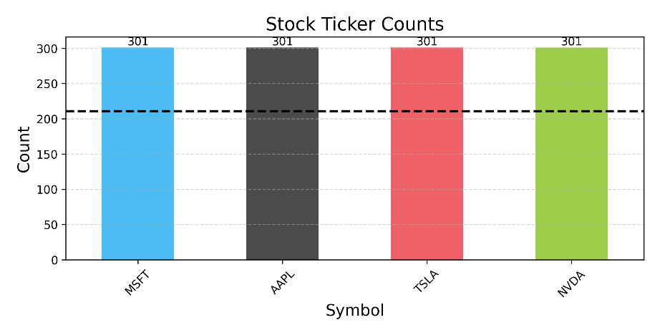Figure 4‑1: Stocks Statistics

Table 4‑2: Price statistics at a glance

|  |  |  |  |  |  |  |
| --- | --- | --- | --- | --- | --- | --- |
|  | Date | Close | Open | Volume | High | Low |
| count | 1204 | 1204 | 1204 | 1204 | 1204 | 1204 |
| mean | 08-08-2023 | 284.51 | 284.11 | 66666277.41 | 288.17 | 280.20 |
| min | 03-01-2023 | 108.10 | 103 | 10176600 | 111.75 | 101.81 |
| 25% | 21-04-2023 | 185.63 | 185.46 | 35229700 | 187.31 | 183.49 |
| 50% | 09-08-2023 | 249.76 | 249.14 | 50882050 | 254.01 | 244.93 |
| 75% | 24-11-2023 | 345.14 | 345.72 | 92418075 | 347.77 | 340.36 |
| max | 14-03-2024 | 926.69 | 951.38 | 306590600 | 974 | 896.02 |
| std |  | 131.18 | 131.16 | 45227548.88 | 133.25 | 128.71 |

* Total of 1204 rows with each stock having 301 OHLV records and 70% of it (211 records, represented by black dotted line) is used for training.
* The study will focus on Close primarily and technical features derived of it.

### Sentiment history at a glance

Table 4‑3: Sentiment Statistics

|  |  |  |  |  |  |
| --- | --- | --- | --- | --- | --- |
|  | Date | Bearish | Bullish | Neutral | Bull/Bear Ratio |
| count | 1422 | 1422 | 1422 | 1422 | 1422 |
| mean | 30-07-2023 | 204.77 | 285.46 | 140.2 | 1.89 |
| min | 06-12-2022 | 1 | 3 | 2 | 0.48 |
| 25% | 03-04-2023 | 36 | 66 | 34 | 1.16 |
| 50% | 30-07-2023 | 83.5 | 148 | 72 | 1.6 |
| 75% | 26-11-2023 | 249.75 | 317 | 159 | 2.26 |
| max | 23-03-2024 | 3230 | 6557 | 3518 | 23 |
| std |  | 314.61 | 464.83 | 225.24 | 1.4 |

## Data Preprocessing

This sub-section involves explaining the preprocessing steps applied on Price and StockTwits data. This will help to ensure that dataset is clean and ready for EDA and application of machine learning models.

### Price – Preprocessing & Trends

This preprocessing stage involves following observations:

* No NaN or NULL records present and hence no additional imputation is required
* No duplication and hence no deletion is required

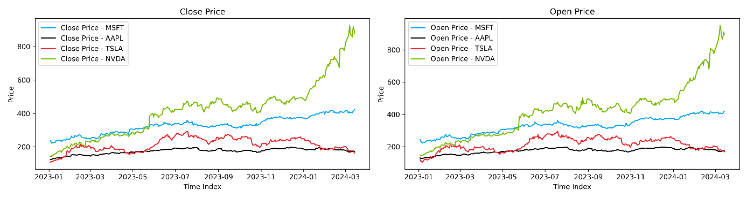

Figure 4‑2: Price Trend – Close and Open

* Figure 4‑2: Price Trend – Close and Open below shows the trend for the 4 stocks for selected duration; MSFT and NVDA (in particular) have shown a significant uptrend on the back of Open AI integration and increased influence of GPU adoption in AI (AI being top focus area recently).

### Outlier detection

Figure 4‑3: Close price outlier detection , below, box plot shows that there are some outliers on NVDA ticker explained by the prevailing bullish a bullish sentiment trend on the back of all the innovation happening in the AI space.

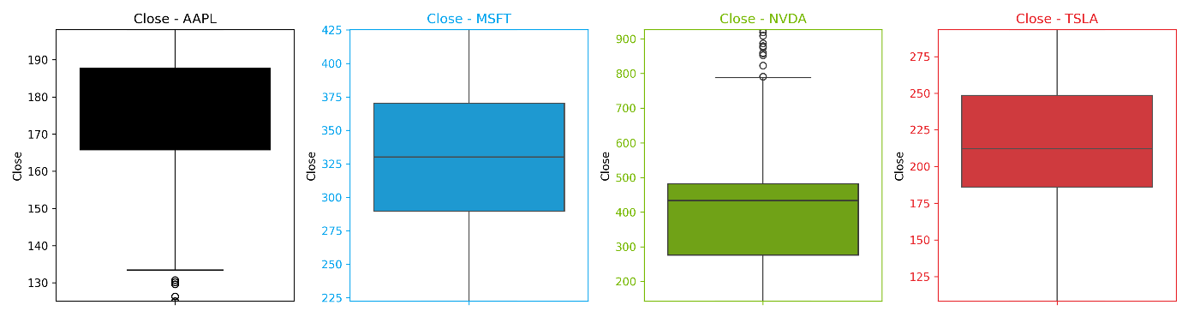

Figure 4‑3: Close price outlier detection

### StockTwits

As explained in 3.3.2. Sentiment Prediction Algorithms, VADER is apt at processing raw social media tweets, effectively considering elements like punctuation (including exclamation marks), capitalization and emoticons. It employs a lexicon-based approach to analyse sentiment, thereby accommodating the nuances in text formatting and style. Consequently, to maintain the integrity and context of the received tweets, this research deliberately refrained from applying any preprocessing techniques to the raw tweet data. The primary objective was to retain the original context and domain-specific language inherent in the tweet text, serving as a crucial measure to avoid excessive manipulation of the original content.

However, as part of experimentation and EDA purpose, following operations are performed on tweet and stored in a new column “clean_tweet”:

* Convert the tweet to lower case
* Apply contraction
* Stop word removal
* Removal of HTML tags/links/punctuation etc

## Feature Engineering

### Price – Technical indicator

Stock price history table feature engineered for:

* MA5
* MA10
* MA20

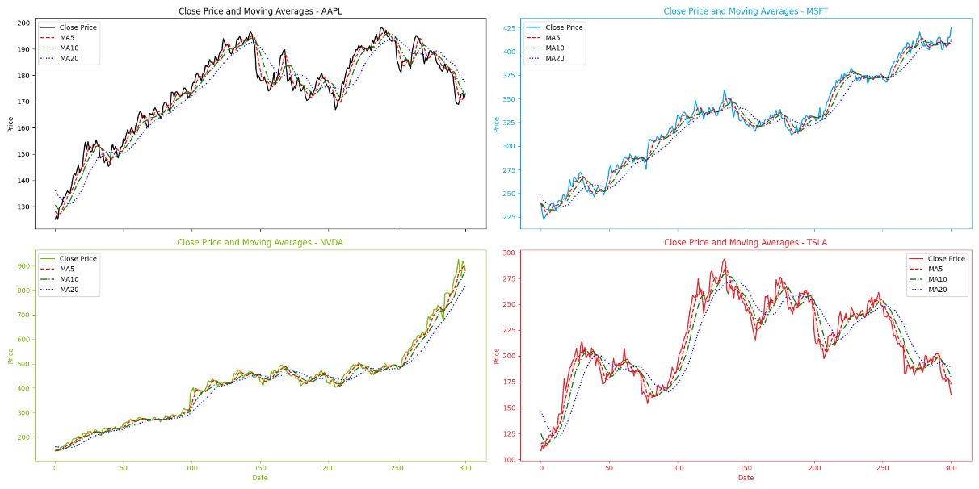

Figure 4‑4: Moving Averages tracking Cloe price

Clearly, the above graph depicts that best values to measure the moving average are 10 and 20 days as it captures trends closely and without noise.

### StockTwits

#### Sentiment Score

VADER sentiment analyser is applied to the cleaned tweets, resulting in the generation of a compound score called Sentiment Score.

#### Sentiment [ Bullish, Bearish and Neutral]

Sentiment score thresholds [Lower: (-0.05,0.05) and Higher: (-0.5,0.5)] helped derive Positive, Negative and Neutral trend of a tweet. Experimentation showed that lower range of threshold was not emitting strength of sentiment and capturing false Bullish tweets.

#### Bull To Bear Ratio

A Bull to Bear ratio was also feature engineered by dividing Bearish count into Bullish Count at a daily frequency to reflect the strength of the Bullish market.

## Exploratory Data Analysis (EDA)

Exploratory data analysis (EDA) involved an in-depth examination of the dataset used in for study to dissect it in multiple dimensions so that a thorough understanding of the data is achieved. This section explores various aspects of the data, including the distribution of stock prices, sentiment scores derived using VADER, and any potential correlations between sentiment and stock price movements. EDA focussed on following key-points:

* Explore the data and identify the story of stocks
* Validate each and every feature and identify its relevance
* Perform univariate and bivariate analysis.
* Identify any corelation that exists

### EDA for Price History

This section explores the distribution of stock prices, statistical measures such as mean, median, standard deviation, and quartiles to summarize the central tendency and variability of stock prices. Plots are used to visualize the distribution of stock prices over time, providing insights into trends, seasonality, and volatility.

#### Daily Price Movement:

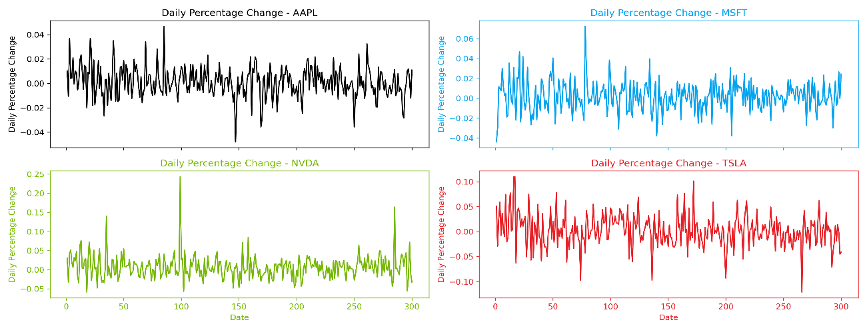

Figure 4‑5: Daily price movement

The daily price movement chart illustrates that price changes typically exhibit a stationary pattern, yet occasional abnormal spikes suggest shifts in market sentiment during those periods. Notably visible in some spikes seen in the recent runs of NVDA.

#### Expected Returns

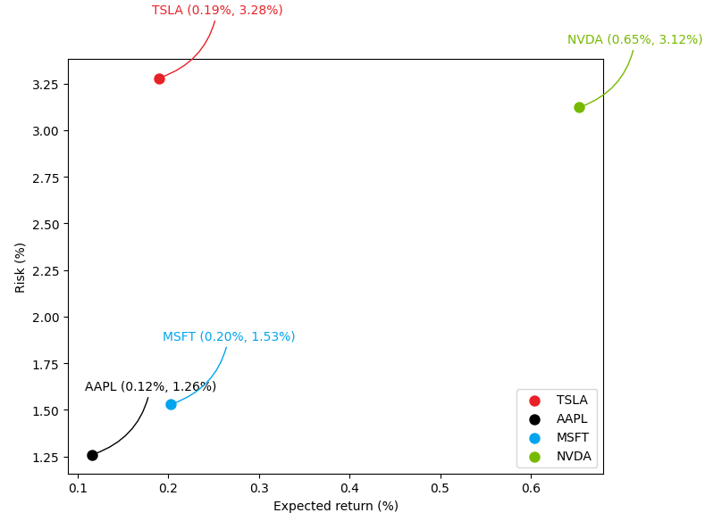

Figure 4‑6: Stock wise Expected Returns

* NVDA exhibits the highest mean return and standard deviation of returns, indicating potentially higher returns but also higher risk.
* AAPL and MSFT have relatively lower mean returns and lower standard deviations of returns, suggesting lower risk but also potentially lower returns.
* TSLA falls between NVDA and AAPL/MSFT in terms of mean return and standard deviation of returns, indicating moderate risk and potential returns.

#### Heatmap of Price Correlation

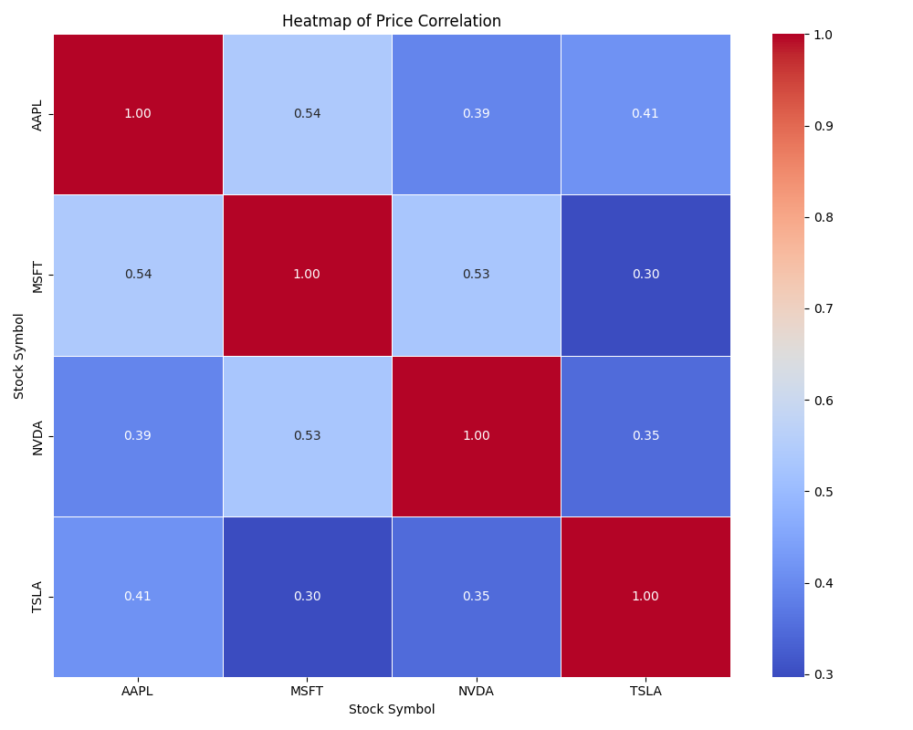

Figure 4‑7: Heatmap for price correlation

* MSFT and NVDA: A moderately positive relationship, with a coefficient of approximately 0.53. This correlation may be attributed to their involvement in the realm of artificial intelligence (AI) development, with both companies leveraging each other's expertise and technologies to advance their respective AI-driven initiatives and product offerings.
* AAPL and MSFT: The correlation analysis reveals a notably positive relationship between the performance of the stocks, evidenced by a correlation coefficient of approximately 0.54. This correlation may reflect the interdependence stemming from their collaborative efforts in technological advancements, such as cross-platform integrations and joint ventures in cloud computing services.
* AAPL and NVDA: While a positive correlation exists, it appears comparatively weaker, standing at around 0.39. This correlation, though not as robust, could still be influenced by indirect associations, such as shared market segments.

### EDA for Sentiments

The study focusses on the impact of sentiment factors, such as sentiment polarity and understand the stocktwits sentiments.

#### Sentiment Count

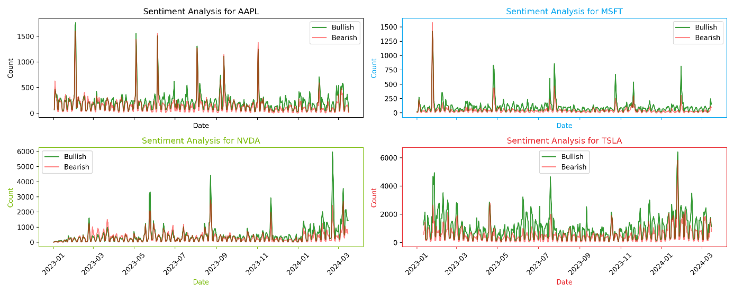

Figure 4‑8: Sentiment count aggregate

* At a high level, above graph reveals a near equilibrium between the volume of daily bearish and bullish tweets. This balance suggests a lack of discernible trend in sentiment over the analysed period. Despite fluctuations in sentiment, the absence of a clear predominance of either bullish or bearish sentiment makes it challenging to identify any overarching sentiment trajectory from the data alone.

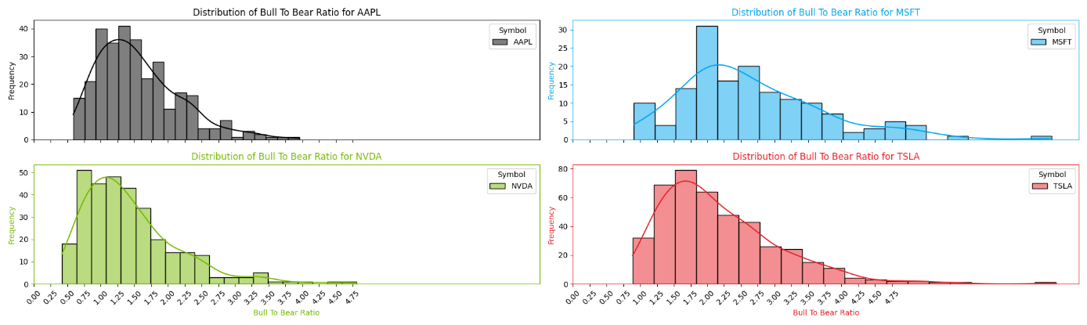

Figure 4‑9: Bull to Bear Ratios (Bullish tweet >=50)

* Noteworthy spikes in the Tweet Count and Bull-To-Bear Ratio occur on select dates within the analysed range. To gain deeper insights into these spikes, it is imperative to correlate them with the corresponding price action. By juxtaposing the spikes in sentiment with fluctuations in the stock's performance, it becomes possible to discern potential correlations between sentiment shifts and changes in market behaviour. Bull to Bear Ratio

#### Tweet Volume

#### Monthly Bearish and Bullish Comparison

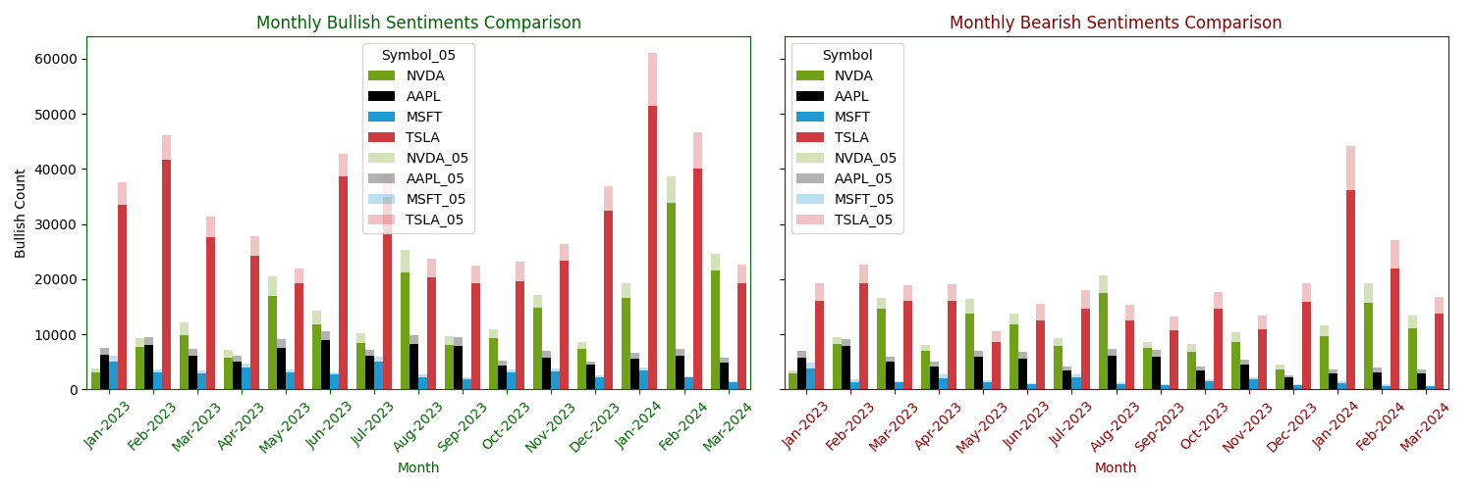

Figure 4‑10: Monthly tweet comparison

* Observing the graph above (Bullish to left), it appears that there is a discernible inclination towards a Bull market sentiment prevailing throughout the analysed range, with a notable amplification observed particularly during the year 2024.

#### Word Cloud

##### All tweets

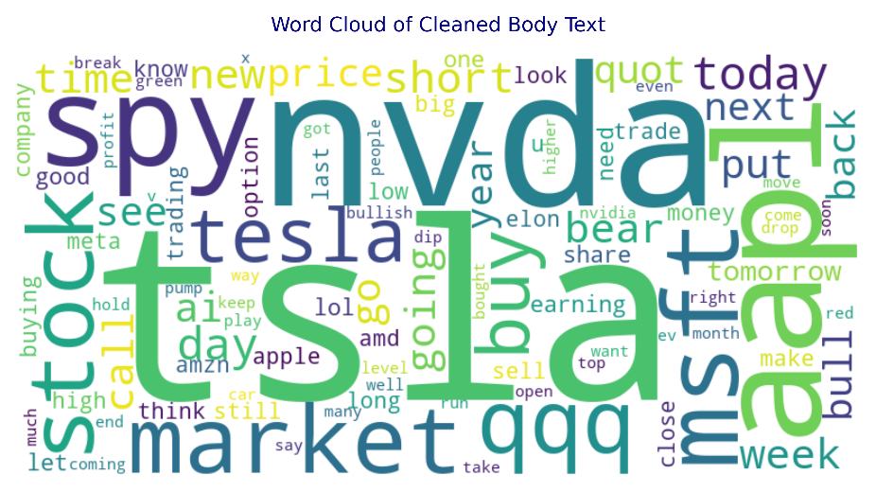

Figure 4‑11: Word count aggregate

##### Stock Level

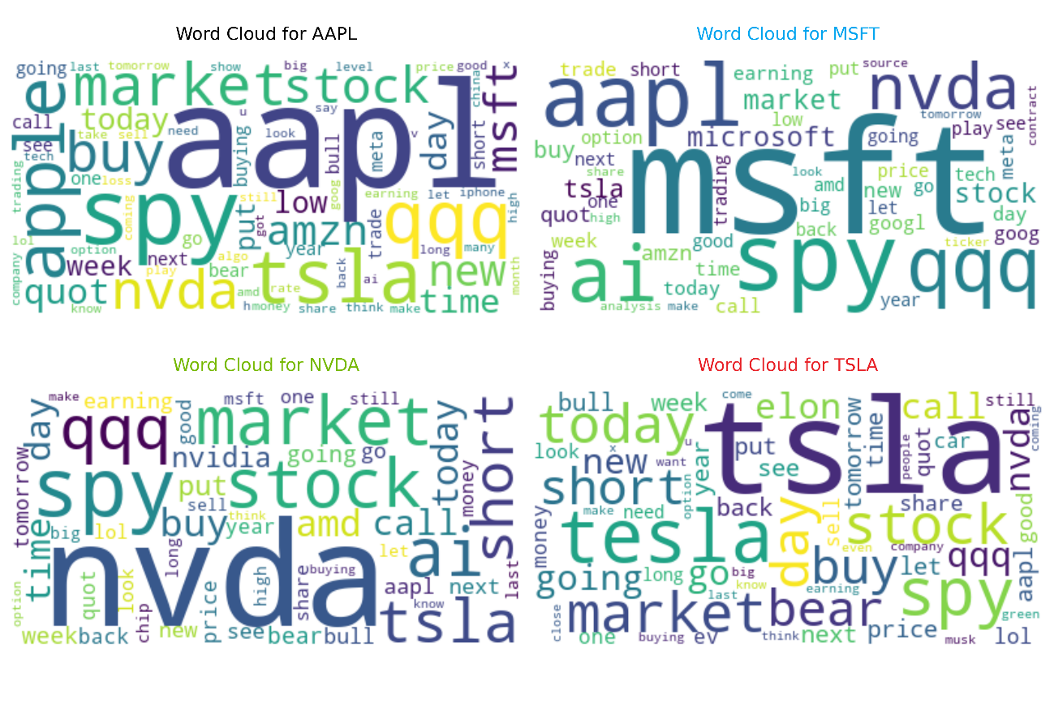

Figure 4‑12: Word count detailed

* TSLA and NVDA are prominent attraction area.
* MSFT tweets also references NVDA and AAPL in the same breath (as clarified in 4.5.1.3. Heatmap of Price Correlation)

#### Corelation Analysis – Tweet Volume and Price Action

A thorough discussion on corelation analysis is being deferred to the next Chapter 5: Results & Discussion.

## Model Building and Tuning

This section implements proposed ML models described in Section 3.3 Algorithm Selection Rational3.3. The research will engage in following distinct methodologies:

* VADER for sentiment analysis
* LSTM (Long Short-Term Memory) as a standalone price predictor
  + Short range - 1-year range
  + Long range - 5-year range
* Deep Q-Network as portfolio strategy predictor

This section will share a comprehensive analysis keeping the strengths, weaknesses of each model.

### VADER

#### Model build/Tuning

VADER offered following parameter and a subset of which was chosen to experiment to meet the objective of the research.

Table 4‑4: VADER Model parameters description

|  |  |  |
| --- | --- | --- |
| Parameter | Description | Reasoning |
| Lexicon Size | Number of words and phrases in the VADER lexicon. | A larger lexicon can capture a wider range of sentiment expressions, potentially improving sentiment analysis coverage. |
|  |  |  |
| Scoring Thresholds | Predefined thresholds for sentiment classification (positive, negative, neutral). | Adjusting thresholds can fine-tune the sensitivity and specificity of sentiment classification, optimizing sentiment analysis performance. |
|  |  |  |
| Sentiment Intensity Thresholds | Thresholds for distinguishing between mild, moderate, and strong sentiment expressions. | Intensity thresholds provide granularity in sentiment analysis, enabling differentiation between subtle and strong expressions of sentiment. |

##### Tuning Lexicon Size

VADER is not a trainable model (i.e. Transfer learning), there are no traditional model parameters to tune which can be applied to the social media tweets however it may not be directly adaptable to the stock tweets which are domain specific. The study identified the domain specific words and enriched the VADER lexicon for the same.

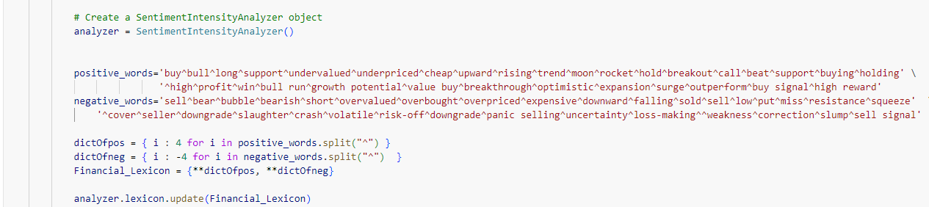

Figure 4‑13: Tuning Lexicon Size

##### Tuning Scoring Thresholds

Once VADER is applied to a given text, VADER assigns sentiment scores (positive, negative, neutral, and compound) to each text or sentence based on the presence of words with known sentiment polarity in its lexicon.

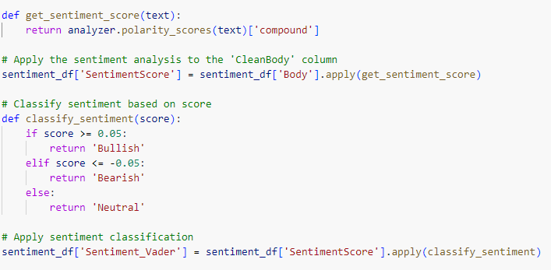

Figure 4‑14: Tuning Scoring Thresholds

The study experimented with two thresholds [ (-0.05, 0.05), (-0.5, 0.5)]; after careful evaluation, a threshold of (-0.5, 0.5) was chosen.

### LSTM Only

The study delved into the intricacies of the training algorithm employed for LSTM (Long Short-Term Memory) model.

#### Model Architecture

Physical level implementation of the logical architecture (as illustrated in Figure 3‑3: Long Short-Term logical architecture) is depicted below:

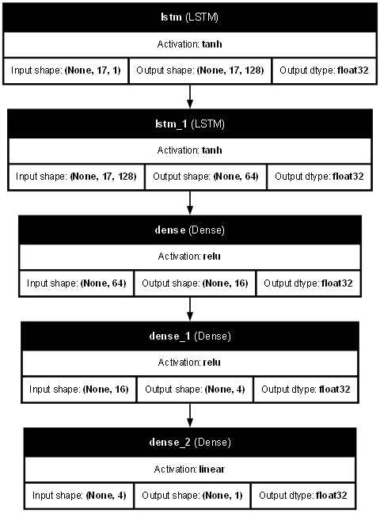

Figure 4‑15: Physical model architecture

#### Model Parameters

LSTM based Deep Neural Network (DNN) architecture is designed to capture complex patterns and relationships corresponding stock price movements. The architecture consisted of multiple layers, each serving a specific purpose in the feature extraction and prediction process. Table below describes the important model parameter to consider for optimizations:

Table 4‑5: LSTM Model parameters description

|  |  |  |
| --- | --- | --- |
| Component | Description | Reasoning |
| Input Layer | Input shape:  Features: Adj Close, MA5, MA10, MA20 | Time steps: Determined by historical data sequence |
| LSTM  Layers | # of LSTM layers:  Variable [1, 2, 3] | Allow flexibility |
|  | Hidden units per layer:  Variable [64, 128, 192, 256] | Tunable for balancing model complexity and performance |
|  | Activation function: 'tanh' | Commonly used activation function for LSTMs |
|  | Dropout rate:  Variable [0.1, 0.15, 0.2] | Regularization to prevent overfitting |
|  | Return sequences:  True (False for final layer) | Needed for stacking multiple LSTM layers |
| Output Layer | Number of units/neurons: 1 | Output is a single value for regression |
|  | Activation function: relu | Relu activation function for regression |
| Compile Parameters | Loss function:  Variable ['mse', 'mae’] | Tunable loss function for model optimization |
|  | Optimizer: Adam | Adam optimizer commonly used for its efficiency |
|  | Learning rate: Variable  [0.001, 0.0001] | Adjustable learning rate for optimizer |
| Training Parameters | Batch size: [16, 64] | Tunable batch size for training data |
|  | Number of epochs: max 50 | Adjustable number of epochs for training |

The criteria for selecting optimal hyperparameters revolve around maximizing training performance metrics such as validation loss convergence. The ultimate goal is to identify hyperparameter configurations that facilitate robust model training, ensuring effective prediction capabilities on unseen data.

#### Model Parameter Tuning

The tuning strategy leveraged Keras Tuner, a powerful tool for hyperparameter optimization. Keras Tuner offers an efficient approach to exploring the hyperparameter space, automating the process of selecting the optimal configuration for the LSTM model. It provides 3 different ways to hyper tune the given model; listed below:

##### Random Search

Random Search is a widely-used hyperparameter optimization algorithm due to its simplicity and ease of implementation. It randomly samples hyperparameter combinations from a predefined search space and evaluates their performance. While Random Search can be computationally efficient, its random nature may lead to suboptimal solutions, particularly in high-dimensional search spaces. Moreover, it does not adapt its search strategy based on past evaluations, potentially leading to inefficient exploration of the hyperparameter space.

##### Bayesian Optimization

Bayesian Optimization is a probabilistic model-based optimization technique that leverages Bayesian inference to guide the search process. By constructing a probabilistic surrogate model of the objective function, Bayesian Optimization efficiently balances exploration and exploitation, converging to near-optimal solutions with fewer evaluations compared to Random Search. However, Bayesian Optimization's effectiveness depends heavily on the choice of the surrogate model and its associated hyperparameters, which can introduce additional complexity and computational overhead.

##### Hyperband

Hyperband combines the efficiency of random search with a principled early-stopping mechanism inspired by successive halving. It systematically allocates resources to different hyperparameter configurations, focusing computational effort on the most promising candidates. Hyperband's ability to identify and discard poor-performing configurations early in the search process makes it particularly well-suited for large-scale hyperparameter optimization tasks. Additionally, its adaptive resource allocation strategy allows for efficient exploration of the hyperparameter space without the need for manual tuning or domain knowledge.

After conducting a thorough review of the three available methodologies for hyperparameter tuning, the selection process culminated in the adoption of Hyperband as the preferred approach for hyperparameter tuning as show in the Figure 4‑16: Hyperparameter Tuning for LSTM Model.

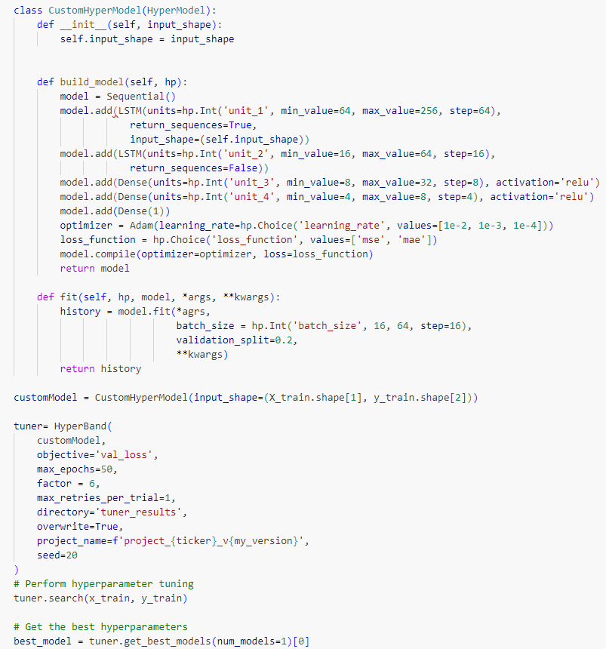

Figure 4‑16: Hyperparameter Tuning for LSTM Model

### Deep-Q-Network

This section deals with the Deep Reinforcement Learning algorithms to come up with the portfolio value based on the initial portfolio cash and stocks. We conduct a comprehensive analysis of our predictive models and examine their performance in computing the trading model-based portfolio value.

#### Model Architecture

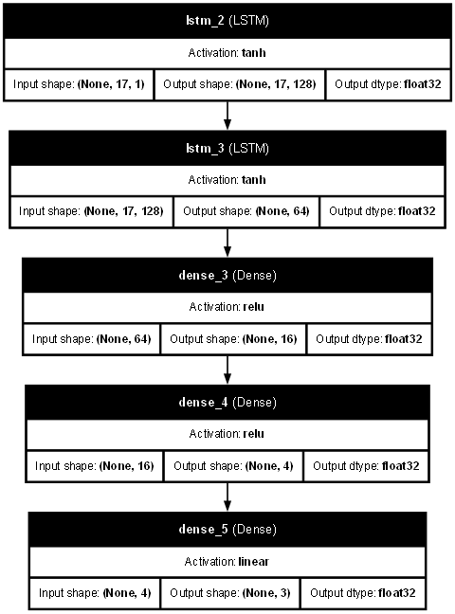

Figure 4‑17: Physical LSTM model architecture used with RL

#### Model Parameter Tuning

#### Reward Function Design

In crafting an effective Deep-Q_Network algorithm, a pivotal aspect lies in the meticulous design of the reward function. This function serves as the guiding light, directing the agent towards actions that lead to desirable outcomes, such as maximizing profit or outperforming a chosen stock strategy.

A well-designed reward scheme should seamlessly align with the overarching goal, reflecting the objective of profit enhancement (as illustrated in Table 4‑6: Reward Function). Integral to this is the inclusion of the current portfolio within the state representation. By granting the agent access to information regarding stock values and cash holdings, it can better assess its actions' impact on future profitability. This direct feedback loop accelerates the learning process, enabling the agent to discern the optimal timing for investment decisions and capitalize on profit opportunities.

Moreover, incorporating a time horizon into the state representation is crucial. Awareness of the impending conclusion ensures that the agent avoids holding onto stocks when it should be liquidating them to meet final evaluation criteria.

Table 4‑6: Reward Function

|  |  |  |  |
| --- | --- | --- | --- |
| Action Type | Buy | Sell | Hold |
| No stock in inventory |  | Punish |  |
| Stock Price > Cash Balance | Punish | Reward |  |
| Cash Balance < 500 | Punish | Reward |  |
| Min Price in inventory > Current Stock Price | Reward | Punish |  |
| Min Price in inventory < Current Stock Price | Punish | Reward |  |
| Positive Price Change | Reward | Punish |  |
| Negative Price Change | Punish | Reward |  |
| Default | Punish | Reward | Punish |

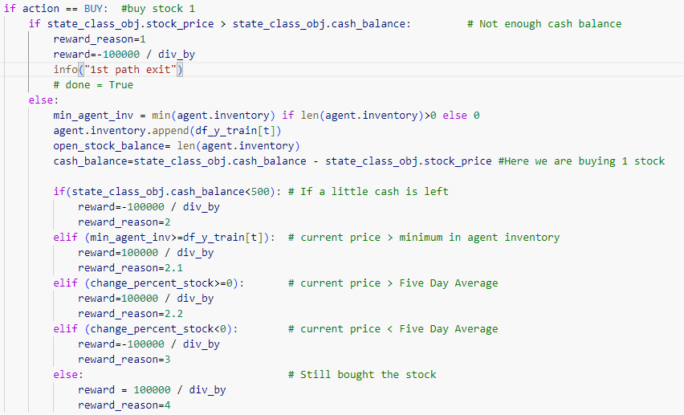

Figure 4‑18: Buy signal reward function

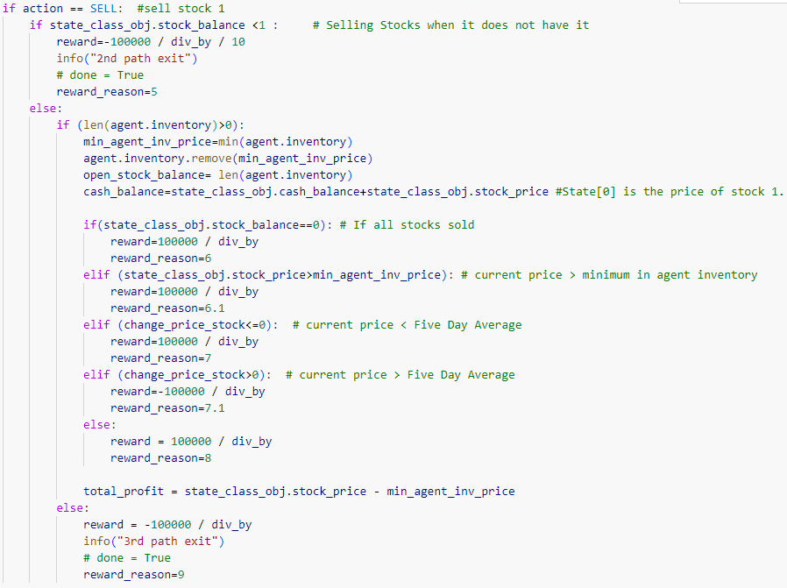

Figure 4‑19: Sell signal reward function

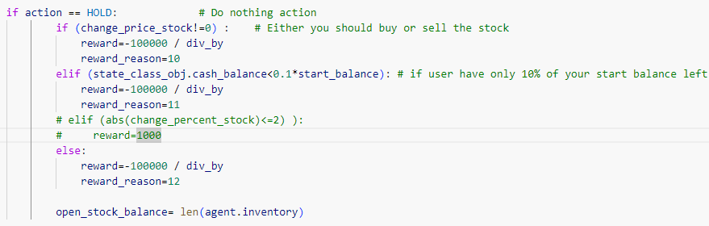

Figure 4‑20: Hold signal reward function

## Summary

This chapter thoroughly examined the dataset and the methodologies employed for preprocessing, feature engineering, exploratory data analysis (EDA), and model development, evaluation, and refinement.

The chapter began with a thorough investigation into data selection, covering both price and sentiment history. Visual representations depicted the predominantly upward-sloping (positive) price trend, accurately monitored by moving-average (5, 10, 20-day) indicators. Technical indicators were then utilized on price data to identify underlying trends and patterns, offering crucial background for further analysis.

Sentiment data from StockTwits underwent meticulous processing to extract meaningful insights, laying the groundwork for subsequent feature engineering effort. Examination of tweets indicated a rising trend in both tweeting activity and sentiment expression. However, it was inconclusive whether a direct correlation exists between price action and tweeting activity.

This led to the derivation of Sentiment Scores and Sentiment Trend using VADER, with experimentation done to sentiment score thresholds to enhance tweet strengths (both bullish and bearish). Furthermore, sentiment-related features such as bull-to-bear ratios were derived showing strengths of Bull tweet with respect to bear tweet which majorly consolidate in the range of 1 to 3.

EDA served as a cornerstone in uncovering hidden patterns and relationships within the dataset. Through various visualizations, including daily price movement charts, heatmaps of price correlation, and comparisons of bullish and bearish tweet volumes, intricate market dynamics and sentiment trends were elucidated. These insights provided a solid foundation for the subsequent model development phase.

The chapter culminated in the model building and tuning phase, where a diverse array of methodologies, including VADER sentiment analysis, LSTM-only models, and LSTM combined with reinforcement learning, were developed. Each approach underwent rigorous optimization, including hyperparameter tuning using keras_tuner, and selection of evaluation metrics to identify the optimal model architecture and parameters.

In summary, this chapter marked the practical phase of the research, focusing on data examination and gaining insights into the factors influencing each stage of model development. Subsequently, these models underwent rigorous evaluation to derive the findings, which will be elaborated upon in the next Chapter 5: Results & Discussion.

# Results & Discussion

## Introduction

This chapter will focus on the results and conclusions derived from the analysis phase. It first explains the various metrics derived for LSTM Model used for Price Action and which were used and compares them to arrive at the best model.

As a next step, Various sentiment scores were created for the input tweet and comprehensive scruitiny was adone to arrive the best threshold for tuning the score. Also, the feature list is identified and its importance is explained. Post that the best identified model of the train data was applied on the test data to comeup with a comparion.

At the end, the study answers the questions which were part of the research questions to find the the corelation between the stock prices and stock sentiment.

## Model Evaluation

### Analysis of Corelation between Tweet Volume and Price Action

#### Tweet Volume to Price Action

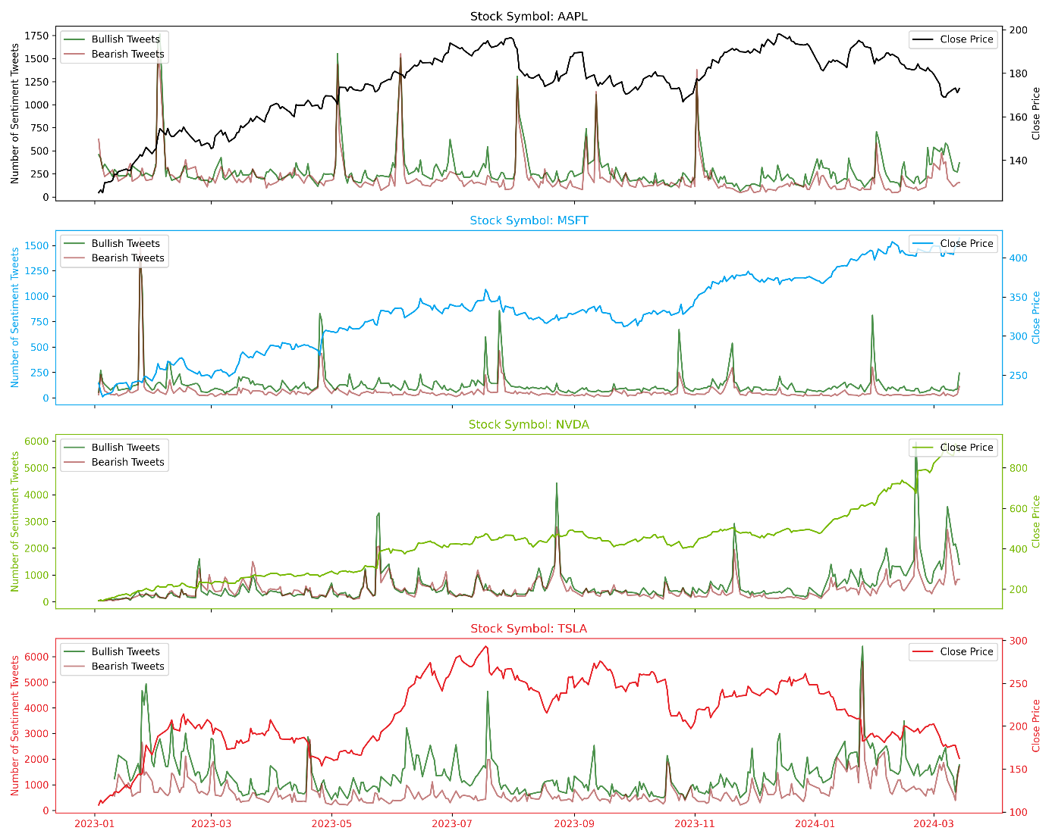

Figure 5‑1: # of tweets & stock price activity

* While examining the two graph (Figure 5‑1, Figure 5‑2), it's apparent that the fluctuations in daily close prices don't exhibit a clear and immediate correlation with the volume of bullish/bearish tweets. Despite fluctuations in sentiment, price movements don't consistently mirror the sentiment expressed on social media.
* Trend Analysis: Over the observed period, it's challenging to discern a discernible trend indicating a direct relationship between bullish sentiment and daily close prices. Although there are instances where sentiment appears to coincide with price movements, these occurrences lack consistency to establish a reliable pattern.
* Outlier: There are occasional outlier days where bullish sentiment experiences significant deviations from its typical levels.

#### Bull/Bear Ratio to Price Action

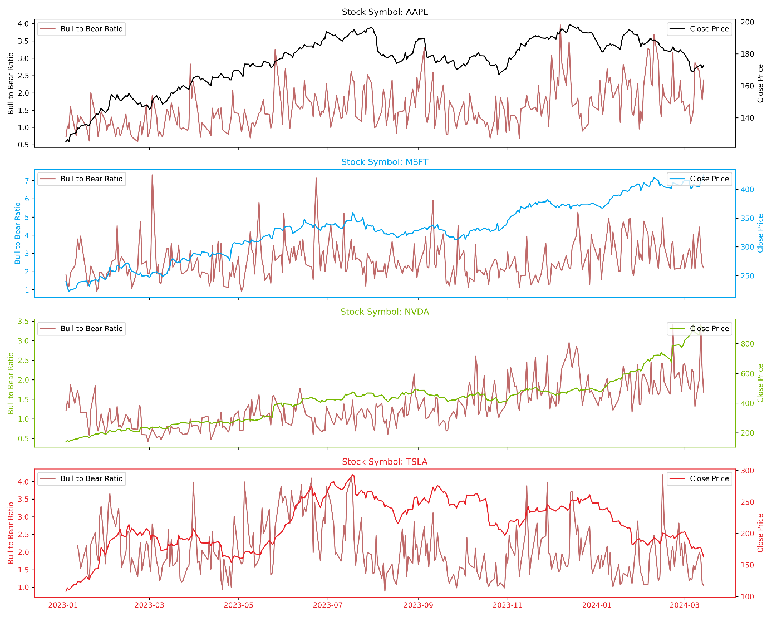

Figure 5‑2: Bull to Bear Ratio and Price Action

* Sentiment Impact: Despite fluctuations in bullish sentiment levels, there's limited evidence suggesting a direct impact on daily close prices. While sentiment may temporarily influence market sentiment, its effect on price action seems to be mitigated by other factors or delayed in its manifestation.
* Long-term vs. Short-term Dynamics: While short-term fluctuations in bullish sentiment may briefly influence market sentiment, their impact on long-term trends in daily close prices appears limited. The absence of sustained correlations over extended periods suggests that short-term sentiment fluctuations may not be reliable predictors of future price movements.
* Event-driven Dynamics: Certain events, such as earnings releases or economic announcements, may coincide with spikes in bullish sentiment. However, the subsequent impact on daily close prices varies, with no consistent pattern indicating a direct causal relationship between event-driven sentiment and price movements.
* Sentiment Lag Effect: There's evidence of a lag effect between shifts in bullish sentiment and their manifestation in daily close prices. While sentiment may initially surge or decline, its impact on market behaviour may not be immediately reflected in price action, suggesting a time delay in the transmission of sentiment to market movements.

The above analysis suggests a lack of direct and consistent relationship between the volume of bullish tweets and daily close prices, despite fluctuations in bullish sentiment. Also as alluded by researcher (Dumiter et al., 2023), despite advancements, there are doubts about measuring market participants' feelings, with concerns raised about subjective and targeted information dissemination. While sentiment may influence market dynamics to some extent, its impact appears to be nuanced and subject to various other factors influencing market behaviour.

### LSTM – Short-range v/s Long Range Training

LSTM worked better for longer training period compared to shorter training period.

However, there are certain caveats while developing the sentiments from the tweets as its reliability may be questioned due to the ambiguity surrounding users' underlying motivations. Another factor to consider is the timing of the tweet in relation to the price action—whether it occurred before (pretty useful for the analysis) or after the price action (than it is just a noise). It is quite possible that more and more users started tweeting as the stock is on uptrend or downtrend and hence sudden jump in the tweet volume could be seen on the charts. So, it's important to understand that an increase in the volume of tweets can sometimes be a common occurrence due to herd mentality.

Elon Musk is publicly accused of market manipulation through public intelligence sources: “According to Reuters, investors are claiming (opens in a new tab) that Musk used his influence on Twitter, TV appearances, and paid online influencers to trade profitably at the expense of other investors (mashable.com/article/elon-musk-dogecoin-lawsuit, accessed on 16 May 2023)”

(Divernois & Filipović, 2023)

### VADER Misclassifications

|  |  |  |
| --- | --- | --- |
| tweet | status | explanation |
| $AAPL Break $140 please. I wanna see $120 by December 16th | VADER Misclassification | Despite VADER's classification as Bullish, the sentiment expressed is actually Bearish. User is expressing a desire for the price of AAPL stock to decrease ("Break $140") and reach $120 by a specified date ("December 16th"). This indicates a pessimistic outlook on the stock's performance, suggesting a belief that its value will decline. |
| Merry Christmas Bulls! $SPY $AMZN $GOOGL $AAPL $TSLA | User Misclassification (deliberate ? ) | User is wishing a "Merry Christmas" to "Bulls", which refers to investors who anticipate rising stock prices. Additionally, the inclusion of stock symbols like $AAPL and $TSLA suggests optimism or positivity towards the performance of these companies' stocks. Therefore, the overall sentiment conveyed in this statement is one of optimism or bullishness. |
| $AAPL  do you think Apple had a bad year? take a look at Tesla Inc. It?s down 50% from its yearly high. Who has shares of Tesla Inc? | VADER Misclassification | While the statement provides information about Tesla Inc. being down 50% from its yearly high, it does not express a clear opinion or sentiment about either Apple Inc. or Tesla Inc. It merely poses a question and provides factual information about the performance of Tesla Inc.'s stock. Therefore, the sentiment in this statement is neutral, as it does not convey positivity or negativity towards either company. |
| $AAPL Cook called off the car because the biggest exec they have plopped this down on Tim?s desk and said. ?Is this good enough?? ?? | VADER Misclassification | The use of phrases like "called off the car" and "Is this good enough?" suggests a decision or action taken by Apple Inc.'s CEO, Tim Cook, that may not meet expectations or may be perceived negatively. This could imply disappointment or concern regarding a project or decision made by the company's leadership, which aligns with a bearish sentiment. |

## Model Validation

### LSTM Model Evaluation

Model underwent following short and long-term training:

1. 5-year data (long duration) with 60 days closing prices
2. One-year data (short duration) with 14 days closing prices

Table 5‑1: LSTM Predicted Close Prices (for a period of 5 years)

|  |  |
| --- | --- |
| **AAPL – Apple** | **MSFT – Microsoft** |
|  |  |
| **NVDA - NVIDEA** | **TSLA - Tesla Inc** |
|  |  |

* Over an extended training period (5-year), the Long Short-Term Memory (LSTM) model demonstrated remarkable precision in tracking stock prices.
* The LSTM model consistently preserved the underlying shape of the stock price trends across various stocks, with one notable exception observed in the case of NVDA stock.
* During a specific period within the training timeframe, NVDA stock exhibited an unprecedented surge, which the LSTM model failed to accurately replicate in its price trend prediction. This discrepancy is further evidenced by the notably high standard deviation observed in NVDA's expected returns, as illustrated in Figure 4‑6: Stock wise Expected Returns

Table 5‑2: LSTM Predicted Close Prices (Analysis Range)

|  |  |
| --- | --- |
| **AAPL – Apple** | **MSFT – Microsoft** |
|  |  |
| **NVDA - NVIDEA** | **TSLA - Tesla Inc** |
|  |  |

* For a shorter duration, approximately one year, the LSTM model demonstrated inconsistency in accurately capturing the underlying shape of stock price trends. It exhibited tendencies of both overestimating and underestimating prices, leading to unreliable predictions.

This observation suggests that when integrating LSTM with reinforcement learning (RL), employing a longer training period might enhance model performance. However, such an approach could significantly escalate resource requirements, potentially exceeding the feasibility of this study. Consequently, this research will prioritize a shorter-term range to maintain practicality and manageability within the available resources.

### Deep-Q-Network

Table 5‑3: DRL at action

|  |  |
| --- | --- |
| **AAPL – Apple Inc** | **MSFT – Microsoft Corp** |
|  |  |
| **NVDA - Nvidia Corp** | **TSLA - Tesla Inc** |
|  |  |

### Comparison of DQN and DDQN

Finally, this subsection outlines the experimental setup for comparing DQN and DDQN algorithms, including variations in hyperparameters or training procedures. It specifies the performance metrics used for comparison and analyses the results of the comparative study. Insights into the relative strengths and weaknesses of DQN and DDQN are provided based on their convergence speed, stability, and final performance on validation data. The goal is to offer readers a comprehensive understanding of the differences between the two algorithms and their implications for stock market prediction tasks.

### Evaluation Metrics:

Define the evaluation metrics used to assess the performance of the DRL model.

Discuss metrics such as average reward per episode, accuracy of sentiment predictions, or correlation between predicted and actual price movements.

In assessing the performance of our predictive models for stock and sentiment analysis, we employ evaluation metrics tailored to our specific use case, emphasizing benchmark return and buy vs. hold comparison. These metrics are crucial in quantifying the effectiveness of our models in generating returns compared to baseline strategies.

We employ a range of evaluation metrics to quantify the performance of our predictive models and gauge their accuracy in predicting stock prices. These evaluation metrics include:

### Benchmark Return:

Benchmark return measures the performance of our predictive models relative to a predefined benchmark, such as a market index (e.g., S&P 500) or a buy-and-hold strategy.

It quantifies the percentage return achieved by our models over a specific period compared to the benchmark return over the same period.

A higher benchmark return indicates that our models outperform the benchmark, demonstrating their effectiveness in generating returns.

### Buy vs. Hold Comparison:

Buy vs. hold comparison evaluates the performance of our predictive models against a simple buy-and-hold strategy, where an investor buys the asset and holds it for the entire period without any trading decisions.

It compares the cumulative return achieved by our models through trading decisions with the return generated by holding the asset without any trading activity.

A positive buy vs. hold comparison indicates that our models add value by making profitable trading decisions beyond what could be achieved through a passive buy-and-hold strategy.

By focusing on benchmark return and buy vs. hold comparison as our primary evaluation metrics, we aim to provide a practical assessment of the performance of our predictive models in real-world trading scenarios. These metrics offer valuable insights into the effectiveness of our models in generating returns compared to baseline strategies, helping investors make informed decisions and optimize their investment portfolios. Through rigorous evaluation and analysis of these metrics, we can gain a deeper understanding of the predictive power and value proposition of our models in the context of stock and sentiment analysis.

This section defines the evaluation metrics used to assess the performance of the trained DRL models and explains the evaluation procedure. Metrics such as cumulative reward and average return are discussed, along with their significance in measuring the effectiveness and generalization capability of the models. The process of evaluating the trained models on held-out validation data or through cross-validation techniques is detailed, emphasizing the importance of robust evaluation in reinforcement learning.

## Research Questions

1. How can SA be leveraged to extract valuable insights from diverse text sources?

Sentiment analysis, also referred to as opinion mining, is a powerful technique for extracting sentiment from text data, including social media posts, news articles, customer reviews, and financial reports. In our study, we leveraged the VADER algorithm to extract sentiment from tweets. While Stocktwits provides user sentiment, our analysis revealed instances where VADER outperformed user sentiment classification, especially when tweets were left untagged and defaulted to neutral. VADER utilizes a lexicon with weighted contexts for words, enabling accurate assessment of social media sentiment. For the stock domain, we enhanced the lexicon to better capture positive and negative sentiments, thereby facilitating extraction of domain-specific tweet sentiment.

Furthermore, domain adaptation is essential for tailoring sentiment analysis models to specific domains, such as finance or healthcare. By fine-tuning the model on relevant data or conducting domain-specific training, we can significantly enhance performance. This adaptation extends beyond tweets to encompass other text sources, including company reports and news articles about the company. By integrating these methodologies, sentiment analysis becomes a powerful tool for extracting valuable insights from diverse text sources, with applications spanning customer feedback analysis, social media monitoring, and market sentiment analysis.

1. How can DRL algorithms be integrated with sentiment analysis to develop decision-making framework for stock trading?

Integrating Deep Reinforcement Learning (DRL) algorithms with sentiment analysis for stock trading involves creating a decision-making framework that learns to make optimal trading decisions based on both market data and sentiment signals. To begin, the state space must be defined, encompassing market data such as stock prices, volumes, technical indicators, and sentiment scores derived from sentiment analysis of relevant news articles, social media posts, or financial reports. Subsequently, the action space is delineated, representing possible trading actions such as buy, sell, or hold, predicated on sentiment and other pertinent factors. A critical aspect of this integration lies in the design of a reward function that effectively incentivizes profitable trading behaviour while penalizing risky or unprofitable actions. This function must encompass both immediate gains from trades and long-term portfolio performance to ensure comprehensive evaluation. With the model architecture established, ranging from Deep Q-Networks (DQN) to Proximal Policy Optimization (PPO), the subsequent step involves training the DRL model on historical market data and sentiment data. This facilitates the model's learning of patterns and correlations between market movements and sentiment signals. Following training, validation through backtesting on historical data is imperative to assess the model's performance and validate its generalization to unseen data. Finally, the trained DRL model is deployed in a real-time trading environment, where it continuously receives market data and sentiment updates, making trading decisions in line with its learned policy. Through this holistic integration, sentiment analysis complements DRL algorithms, empowering the decision-making framework for stock trading with a comprehensive understanding of both market dynamics and sentiment trends.

1. To what extent does the fusion of NLP and DRL improve the accuracy of predicting market moves?

The fusion of Natural Language Processing (NLP) and Deep Reinforcement Learning (DRL) holds immense potential in enhancing the accuracy of predicting market moves. By integrating NLP techniques with DRL algorithms, financial analysts and traders can extract valuable insights from textual data sources such as news articles, social media posts, and earnings reports. This fusion enables the model to capture the sentiment, relevance, and potential impact of information on market movements with greater precision. NLP techniques like word embeddings and topic modelling aid in extracting relevant features from text data, complementing traditional market data to provide a more comprehensive understanding of market dynamics. Furthermore, DRL algorithms allow the model to dynamically learn and adapt to changing market conditions and textual data streams, continuously updating its decision-making policy based on real-time information. The combination of multi-modal fusion, attention mechanisms, and interpretable decision-making facilitated by NLP and DRL enhances the model's predictive accuracy by filtering out noise, focusing on relevant information, and providing transparent explanations for predictions. Domain-specific adaptation of NLP models tailored for the finance domain further contributes to improving prediction accuracy by capturing domain-specific nuances and language patterns essential for accurate market prediction. Overall, the fusion of NLP and DRL empowers traders and investors with actionable insights derived from textual data sources, significantly improving the accuracy of predicting market moves and informing informed decision-making in dynamic financial markets.

## Required Resources

### Hardware Resources

Processor: Intel(R) Core (TM) i5-9300H CPU @ 2.40GHz (or equivalent)

RAM: 8GB

Graphics: Based on the requirements an external GPU can be used

Storage: SSD preferred for faster data access

OS: Windows 10, macOS, or Linux

### Software and Tools

Programming Language: Python 3.7 as it has a support for most of the latest ml algo

Libraries and Framework: TensorFlow, Pytorch, Keras

Data Visualization Tools: Matplotlib, Tableau

### Textual Data Processing Tools

Preprocessing textual data: NLTK (Natural Language Toolkit), Spacy

Web Scrapping: Beautiful Soup

Text processing and analysis: spacy

### IDE – interactive development environment

Jupyter Notebook IDE (based on requirements free GPU resources can be used)

VS-Code

## Summary

In Chapter 5, the study delves into a comprehensive discussion of the results derived from the analysis phase, offering nuanced insights into the application of sentiment analysis, Deep Reinforcement Learning (DRL), and their implications for stock trading decision-making. The discussion commences with an exploration of the phenomenon of model drift, particularly focusing on the misclassifications observed in the VADER sentiment analysis tool. This examination reveals instances where expressed sentiments contradict their assigned classifications, prompting critical reflections on the reliability of sentiment analysis tools in dynamic market environments.

Subsequently, the discussion shifts to model validation, where a meticulous comparison is conducted between LSTM models trained on 5-year and 1-year datasets within the framework of price tracking. Through rigorous analysis, the rationale behind the superior performance of the 5-year trained model compared to its 1-year counterpart is elucidated.

Further, attention is directed towards the application of DRL for portfolio optimization. By conducting thorough evaluations utilizing diverse evaluation metrics, including the DDSS strategy, quantitative insights are gleaned into the efficacy of these models in generating profitable trading strategies.

Throughout this journey, the study rigorously addresses pivotal research questions concerning the integration of sentiment analysis with DRL, aiming to assess the extent to which this fusion can enhance the accuracy of predicting market moves. The findings not only contribute to a deeper understanding of the intricate dynamics within financial markets but also lay the groundwork for future advancements in algorithmic trading strategies.

In essence, This chapter serves as a culmination of our scholarly endeavours, encapsulating the significant progress made in unravelling the complexities of sentiment-driven stock trading decision-making. Moreover, it sets the stage for continued exploration and innovation in this evolving domain.

# Conclusions and Recommendations

## Introduction

This chapter delves into the concluding the study, focusing on the conclusions drawn from the results obtained in the context of the research. The conclusions encapsulate the fulfilment of the study's objectives, shedding light on the attainment of its overarching goals. Additionally, it assesses whether the study effectively addresses all the intended aims.

## Discussion & Conclusions

This study utilized financial markets data encompassing over two datasets (one year and 5 year of stock prices, and related StockTwits tweets) concerning prominent US companies like AAPL, MSFT, NVDA, and TSLA. Within this dataset lie numerous latent patterns, the exploration of which formed a primary objective of this study. The overarching aim was to discern these patterns, establish correlations with price predictions, and enhance portfolio value. In pursuit of the research objectives, the study explored various modelling approaches to assess their effectiveness.

First objective was to establish if the stock price can be predicted reliably given the inherent complexities and uncounted number of variables impacting it in the market scenario. One of the first modelling implemented was LSTM modelling, aimed at predicting prices with respect to test close prices. Utilizing LSTM modelling on both one-year (short-range) and five-year (long-range) datasets, the study sought to identify which dataset more accurately tracked the closing price. Our analysis unveiled a notable correlation between the volume of data and the number of input neurons, with 60 close prices used for training the LSTM model. This correlation was evident in the quality of results depicted in the Price action graphs in Tables 4.6 and 4.7. Noteworthy is the observation that while predictive performance on the one-year dataset was relatively suboptimal, this discrepancy underscored the pivotal role of data range in LSTM modelling. The five-year dataset closely mirrored the test data, underscoring the significance of considering the temporal scope of data inputs in predictive modelling efforts.

Second objective was to augment the predictive power of model by integrating sentiment analysis of tweets and examining its potential correlation with price action in financial markets. To achieve this, the study chose to employ the VADER sentiment (already proven successful for handling social media tweets), which enabled the research to distinguish between bearish and bullish tweets, despite its inherent limitations in handling stock market data post lexicon tuning. Through meticulous threshold tuning (-0.5, 0.5), it refined the sentiment analysis process to capture stronger sentiments, both on the bearish and bullish sides, thereby enhancing the granularity. Interestingly, while stocktwits tweets already contained user sentiment tags, VADER yielded notably improved results, surpassing the efficacy of user sentiment tagging alone. This observation suggests the robustness of VADER in accounting for various behavioural biases that may influence market dynamics, contributing to a more comprehensive understanding of sentiment in financial markets.

However, despite our rigorous efforts and the promising results obtained on tweet classification, The study encountered challenges in establishing a discernible pattern correlating stock sentiment with subsequent price action. This finding underscored the complex and multifaceted nature of market sentiment dynamics, which are influenced by a myriad of factors beyond the scope of sentiment analysis alone. While sentiment analysis provides valuable insights into investor sentiment and market psychology, translating these insights into actionable trading strategies remained a formidable task due to the dynamic and unpredictable nature of financial markets. Consequently, further research is warranted to explore additional variables and methodologies that may facilitate a deeper understanding of the interplay between sentiment and price action, ultimately enhancing the predictive capabilities of financial models in real-world trading environments.

The third and arguably most critical objective of research entailed amalgamating the predictive prowess of the LSTM model, VADER Sentiment analysis, and Reinforcement Learning (RL) algorithm to surpass a predetermined selling strategy. Despite the initial expectation of VADER Sentiment enhancing StockTwits User provided sentiment, as discussed previously, its contribution proved inconclusive due to the inability to establish a consistent correlation between market sentiment and price action. Consequently, The study than focussed solely on leveraging the LSTM model and RL algorithm to optimize performance against the chosen strategy of selling equal shares in ten transactions during the analysis period.

While the Model yielded positive returns, it fell short of outperforming the adopted strategy of Decadal Diversified Selling Strategy (DDSS), with the exception of TSLA which remarkably managed to beat it. This outcome underscored the complexity inherent in optimizing trading strategies, particularly in dynamic and volatile financial markets. This research suggest that further refinement of the reward function, coupled with the utilization of longer-range data, holds potential for surpassing the efficacy of the chosen strategy. Additionally, this underscores the iterative nature of algorithmic trading strategies, emphasizing the need for continuous refinement and adaptation to evolving market conditions.

## Contribution to knowledge

The study, informed by an extensive literature review, identified a gap in existing research pertaining to predictive modelling in financial contexts, particularly regarding price prediction & maximising the portfolio value. While numerous studies have investigated prediction models employing artificial neural networks and ensemble/hybrid approaches, few have been able to generate Risk-Free return. Additionally, literature review revealed a lack of unsupervised learning model with deep learning in the financial markets.

Moreover, the study introduces a novel approach to predict the financial markets. By analysing prediction across short and long-time range, it sheds light on the temporal stability of predictive models. This analysis provides valuable insights into how prediction probabilities vary over time, aiding in the assessment of model robustness and reliability.

## Future recommendation

The study utilized LSTM models for price prediction within both a 1-year and 5-year range. While the 5-year LSTM model closely mimicked the price action, the 1-year model did not perform as effectively.

Additionally, VADER successfully identified stock sentiments after tuning threshold and lexicon updates. However, discerning a clear pattern with stock price action proved challenging.

Furthermore, an attempt was made to enhance predictive capabilities through unsupervised learning combined with LSTM. Although this approach yielded positive returns, it fell short of outperforming Decadal Diversified Selling Strategy; which meant more refinement in the reward algorithms is required.

In light of these findings, future recommendations should focus on refining predictive models, particularly LSTM-based approaches, to better capture short-term fluctuations in stock prices. Additionally, further exploration of sentiment analysis techniques using additional dataset such as news sentiment, corporate earnings report could complement understanding of market dynamics in advance and potentially improve predictive performance.

REFERENCES

1. Medeiros, M. C., & Borges, V. R. P. (2020). Tweet Sentiment Analysis Regarding the Brazilian Stock Market. 71–82. <https://doi.org/10.5753/brasnam.2019.6550>
2. Sahu, S. K., Mokhade, A., & Bokde, N. D. (2023). An Overview of Machine Learning, Deep Learning, and Reinforcement Learning-Based Techniques in Quantitative Finance: Recent Progress and Challenges. In Applied Sciences (Switzerland) (Vol. 13, Issue 3). MDPI. <https://doi.org/10.3390/app13031956>
3. Tao, S. (2023). Predicting BMW Stock Price Based on Linear Regression, LSTM, and Random Forest Regression. In BCP Business & Management EMFRM (Vol. 2022).
4. Lawi, A., Mesra, H., & Amir, S. (2022). Implementation of Long Short-Term Memory and Gated Recurrent Units on grouped time-series data to predict stock prices accurately. Journal of Big Data, 9(1). <https://doi.org/10.1186/s40537-022-00597-0>
5. Kang, C. Y., Lee, C. P., & Lim, K. M. (2022). Cryptocurrency Price Prediction with Convolutional Neural Network and Stacked Gated Recurrent Unit. Data, 7(11). <https://doi.org/10.3390/data7110149>
6. Lin, W., Xie, L., & Xu, H. (2023). Deep-Reinforcement-Learning-Based Dynamic Ensemble Model for Stock Prediction. Electronics (Switzerland), 12(21). <https://doi.org/10.3390/electronics12214483>
7. Lee, Namyeong & Moon, Jun. (2023). Offline Reinforcement Learning for Automated Stock Trading. IEEE Access. PP. 1-1. 10.1109/ACCESS.2023.3324458
8. Zhang, J., & Lei, Y. (2022). Deep Reinforcement Learning for Stock Prediction. Scientific Programming, 2022. <https://doi.org/10.1155/2022/5812546>
9. Yousefi, N. (2022). Deep Reinforcement Learning for Tehran Stock Trading. Indonesian Journal of Data and Science (IJODAS), 3(3), 97–106.
10. Hambly, B., Xu, R., & Yang, H. (2021). Recent Advances in Reinforcement Learning in Finance. <https://doi.org/10.13140/RG.2.2.30278.40002>
11. Fiorini, P. M., & Fiorini, P. G. (2021). A Simple Reinforcement Learning Algorithm for Stock Trading. Proceedings of the 11th IEEE International Conference on Intelligent Data Acquisition and Advanced Computing Systems: Technology and Applications, IDAACS 2021, 2, 824–830. <https://doi.org/10.1109/IDAACS53288.2021.9660900>
12. Awad, A. L., Elkaffas, S. M., & Fakhr, M. W. (2023). Stock Market Prediction Using Deep Reinforcement Learning. Applied System Innovation, 6(6). <https://doi.org/10.3390/asi6060106>
13. Zhang, J., & Lei, Y. (2022). Deep Reinforcement Learning for Stock Prediction. Scientific Programming, 2022. <https://doi.org/10.1155/2022/5812546>
14. Jang, J., & Seong, N. Y. (2023). Deep reinforcement learning for stock portfolio optimization by connecting with modern portfolio theory. Expert Systems with Applications, 218. <https://doi.org/10.1016/j.eswa.2023.119556>
15. Vicari, M., & Gaspari, M. (2021). Analysis of news sentiments using natural language processing and deep learning. AI and Society, 36(3), 931–937. <https://doi.org/10.1007/s00146-020-01111-x>
16. Divernois, M.-A., & Filipović, D. (2023). StockTwits classified sentiment and stock returns. Digital Finance. <https://doi.org/10.1007/s42521-023-00102-z>
17. Shahedul Amin, M., Hossain Ayon, E., Padh Ghosh, B., Salim Chowdhury, M., Shafiquzzaman Bhuiyan, M., Mahmud Jewel, R., & Ali Linkon, A. (2024). Harmonizing Macro-Financial Factors and Twitter Sentiment Analysis in Forecasting Stock Market Trends. <https://doi.org/10.32996/jcsts>
18. Das, N., Sadhukhan, B., Bhakta, S. S., & Chakrabarti, S. (2024). Integrating EEMD and ensemble CNN with X (Twitter) sentiment for enhanced stock price predictions. Social Network Analysis and Mining, 14(1). <https://doi.org/10.1007/s13278-023-01190-w>
19. Jaggi, M., Mandal, P., Narang, S., Naseem, U., & Khushi, M. (2021). Text mining of stocktwits data for predicting stock prices. Applied System Innovation, 4(1), 1–22. <https://doi.org/10.3390/asi4010013>
20. Medeiros, M. C., & Borges, V. R. P. (2020). Tweet Sentiment Analysis Regarding the Brazilian Stock Market. 71–82. <https://doi.org/10.5753/brasnam.2019.6550>
21. Koukaras, P., Nousi, C., & Tjortjis, C. (2022). Stock Market Prediction Using Microblogging Sentiment Analysis and Machine Learning. Telecom, 3(2), 358–378. <https://doi.org/10.3390/telecom3020019>
22. Renault, T. (2020). Sentiment analysis and machine learning in finance: a comparison of methods and models on one million messages. Digital Finance, 2(1–2), 1–13. <https://doi.org/10.1007/s42521-019-00014-x>
23. Swathi, T., Kasiviswanath, & N., & Rao, & A. A. (n.d.). An optimal deep learning-based LSTM for stock price prediction using twitter sentiment analysis. <https://doi.org/10.1007/s10489-022-03175-2/Published>
24. Liu, R., Shi, Y., Ji, C., & Jia, M. (2019). A Survey of Sentiment Analysis Based on Transfer Learning. In IEEE Access (Vol. 7, pp. 85401–85412). Institute of Electrical and Electronics Engineers Inc. <https://doi.org/10.1109/ACCESS.2019.2925059>
25. Muhammad, T., Aftab, A. B., Ahsan, Md. M., Muhu, M. M., Ibrahim, M., Khan, S. I., & Alam, M. S. (2022). Transformer-Based Deep Learning Model for Stock Price Prediction: A Case Study on Bangladesh Stock Market. <https://doi.org/10.1142/S146902682350013X>
26. dos Santos Neto, M. V., da Silva, N. F. F., & da Silva Soares, A. (2023). A survey and study impact of tweet sentiment analysis via transfer learning in low resource scenarios. Language Resources and Evaluation. <https://doi.org/10.1007/s10579-023-09687-8>
27. Lussange, J., Lazarevich, I., Bourgeois-Gironde, S., Palminteri, S., & Gutkin, B. (2021). Modelling Stock Markets by Multi-agent Reinforcement Learning. Computational Economics, 57(1), 113–147. <https://doi.org/10.1007/s10614-020-10038-w>
28. Canese, L., Cardarilli, G. C., di Nunzio, L., Fazzolari, R., Giardino, D., Re, M., & Spanò, S. (2021). Multi-agent reinforcement learning: A review of challenges and applications. In Applied Sciences (Switzerland) (Vol. 11, Issue 11). MDPI AG. <https://doi.org/10.3390/app11114948>
29. Hambly, B., Xu, R., & Yang, H. (2021). Recent Advances in Reinforcement Learning in Finance. <https://doi.org/10.13140/RG.2.2.30278.40002>
30. Fang, Y., Tang, Z., Ren, K., Liu, W., Zhao, L., Bian, J., Li, D., Zhang, W., Yu, Y., & Liu, T. Y. (2023). Learning Multi-Agent Intention-Aware Communication for Optimal Multi-Order Execution in Finance. Proceedings of the ACM SIGKDD International Conference on Knowledge Discovery and Data Mining, 4003–4012. <https://doi.org/10.1145/3580305.3599856>
31. Zou, J., Lou, J., Wang, B., & Liu, S. (2024). A novel Deep Reinforcement Learning based automated stock trading system using cascaded LSTM networks. Expert Systems with Applications, 242. <https://doi.org/10.1016/j.eswa.2023.122801>
32. Sun, Q., Gong, X., & Si, Y. W. (2023). Transaction-aware inverse reinforcement learning for trading in stock markets. Applied Intelligence, 53(23), 28186–28206. <https://doi.org/10.1007/s10489-023-04959-w>
33. Xu, R., Yang, H., & Hambly, B. (2021). Recent Advances in Reinforcement Learning in Finance. <https://www.researchgate.net/publication/356598345>
34. Dumiter, F. C., Turcaș, F., Nicoară, Ștefania A., Bențe, C., & Boiță, M. (2023). The Impact of Sentiment Indices on the Stock Exchange—The Connections between Quantitative Sentiment Indicators, Technical Analysis, and Stock Market. Mathematics, 11(14). <https://doi.org/10.3390/math11143128>
35. Li, H., & Hai, M. (2024). Deep Reinforcement Learning Model for Stock Portfolio Management Based on Data Fusion. Neural Processing Letters, 56(2). <https://doi.org/10.1007/s11063-024-11582-4>
36. Aken, J., Liang, D., Lin, Z., & Wang, C. (2023). The Application of Deep Reinforcement Learning in Stock Trading Models. Advances in Economics, Management and Political Sciences, 39(1), 215–223. <https://doi.org/10.54254/2754-1169/39/20231973>

# Research Proposal

AN NLP AND DRL APPROACH TO SENTIMENT-BASED

STOCK MARKET ANALYSIS FOR INVESTMENT DECISION

ratish moondra

Research Proposal

February 2024

###### Abstract

The stock market, critical for both global and national economies, has experienced significant growth and volatility across the world. It exerts significance influence on economic and decision-making ability of various stakeholder e.g. individual investors, financial analysts, traders, and market practitioners. Consequently, stakeholders are quite keen on achieving accurate prediction.

Despite great advancements in AI and ML, predicting future stock prices remains challenging but advantageous task at the same time and an area of active research. This study aims to integrate Deep Reinforcement Learning (DRL) and Sentiment Analysis (SA) to create a robust investment decision system. By utilizing NLP techniques and establishing corelation with historical price data, the framework aims to extract textual sentiments and improve investment decisions. This research contributes to enhancing Stock Market Prediction (SMP) methodologies and providing insights for navigating through the modern financial markets. From modelling perspective, the proposed research methodology will infuse Sentiment Analysis (to extract sentiment score i.e. positive, negative or neutral), combine it with Deep neural network (i.e. Long Short-Term Memory) & Unsupervised learning technique (Reinforcement Learning) to understand the hidden data patterns & corelations; thereby maximizing the reward function to help investor makes a right decision and improve profitability and reduce possible losses.

###### Background

Stock markets are an important pillar for Global and National businesses & economy. They have experienced an unprecedented growth increasingly lucrative but fairly complex and high-risk space due to its volatile nature or agility. Anticipating future stock prices, termed Stock Market Prediction, remains an area of immense interest for academics, researchers, and economists alike. Recent advancements in the field of Sentiment Analysis, Artificial Intelligence, and Machine Learning have introduced novel perspectives into decision-making processes for investors. Researcher have tried to use a range of traditional algo such as Random Forests, Timeseries, Support vector machine algorithms to latest deep neural network-based algorithms. Most recently (Zou et al., 2024) used Neural Networks such as cascaded LSTM framework at deciphering patterns from historical data and focussed on increasing Cumulative Return (CR), MER (maximum earning rate) and Average profitability thereby improving range from 5% to 52% depending on a combination of metric and respective stock index.

However, the challenge persists in how predictive/deep learning models react or adapt to unexpected/unforeseen market events influenced by different factors such as macro or micro economic tendencies, sovereign GDP/economy, market subtleties, companies’ growth prospects, consumer prices, central bank policies, and industry-specific nuances. Sahu (Sahu et al., 2023) described a plethora of algorithms and their families being applied in this space and keep the researchers most current. He also underlines the fact that DRL agents, combining price prediction and trading signal, have been deployed for automated trading systems. The fusion of diverse data points such as Technical Analysis (TA) (i.e. a methodology to predict stock movement using historical prices (open, close, high, low), volume), and Sentiment Analysis (SA) for extracting the mood of the market, presents a promising avenue for employing greater influence on investment decisions.

This research endeavours to amalgamate DRL (Jang & Seong, 2023)and SA to formulate a robust decision-making system. DRL, processing multidimensional data spaces to generate actions without supervision, addresses challenges posed by incomplete information or various external economic factors. The proposed contributions include:

* Leveraging NLP for preprocessing texts such as tweets to extract sentiments
* Historical price data extraction for various stocks
* Utilization of LSTM with Reinforcement Learning for pattern/corelation in stock data.

###### Related Works

Recent years have seen the integration of NLP and DRL techniques in stock market analysis and has gathered significant attention. To delve into the topic, I embarked on a thorough literature journey, tapping into various academic and scientific platform such as Google Scholar, Scopus, Springer, ScienceDirect, IEEE Xplore to unearth articles from reputable research journals and publications. This section provides a comprehensive review of relevant literature, outlining various methodologies, algorithms, and approaches employed for predicting market movements in a categorical manner.

* + 1. Researches/Papers related to Deep Reinforcement Learning

(Zou et al., 2024) proposed a novel automated stock trading system that leverages cascaded Long Short-Term Memory (LSTM) networks within a Deep Reinforcement Learning (DRL) framework. By combining the sequential learning capabilities of LSTM networks with the decision-making power of reinforcement learning, the authors achieved impressive range from 5% to 52% depending on the metric (CR, MER and average profitability per trade) and stock index. Similarly, (Aken et al., 2023b) explored the application of DRL in stock trading models, emphasizing the adaptability and learning capacity of reinforcement learning agents. (Awad et al., 2023) and (Yousefi, 2022) extended this research by employing DRL techniques for stock market prediction, exhibiting its potential in forecasting market trends and optimizing trading decisions. (Jang & Seong, 2023) attempted to extend the application of DRL to portfolio optimization, signifying the efficacy of combining reinforcement learning with modern portfolio theory and not just the price prediction. In other part of finance such as cryptocurrency price prediction, (Kang et al., 2022) applied 1-dimentional CNN and GRU architectures (1DCNN-GRU) and their experiments showed that their methodology outstripped existing models with a lowest RMSE of 43.933, 3.511 and 0.00128 on the Bitcoin, Ethereum and Ripple dataset respectively. Moreover, (Lawi et al., 2022) implemented LSTM and GRU architecture on grouped time-series data to accurately forecast stock prices, their experiments demonstrated highest accuracy 97.37% (MAPE) and 96.60% (RMSPE) for validation results of the testing data using GRU Model-1.

* + 1. Researches/Papers related to Sentiment Analysis

The relationship between sentiment analysis and stock market prediction has been extensively explored in the literature. (Koukaras et al., 2022) utilized microblogging sentiment analysis coupled with ML to predict stock market trends based on social media sentiments. By analysing the sentiment expressed in online conversations and social media posts, the authors demonstrated that the best results were obtained when tweets were analysed using VADER and SVM. The results were 76.3% and 67% for F-score and Area Under Curve (AUC) respectively.

* + 1. Researches/Papers related to Hybrid or multiple modelling

(Tao, 2023) integrated Linear Regression, LSTM, and Random Forest Regression models for predicting BMW stock prices, leveraging the complementary strengths of different algorithms to enhance predictive performance; He concluded MLR (multiple linear regression) produced best RMSE of 1.238 (lowest among MLR, LSTM and Random Forest). (Lin et al., 2023) proposed a dynamic ensemble model for stock prediction based on Deep Reinforcement Learning (DRL), demonstrating that MSE touched 0.011 and 0.005, Sharpe ratio (SR) touched 2.20 and 1.53, and CR touched 1.38 and 1.21 in SSE 50 and NASDAQ 100 datasets.

* + 1. Researches/Papers related to ML in Quantitative Finance

(Sahu et al., 2023) provided a comprehensive overview of machine learning, deep learning, and reinforcement learning-based techniques in quantitative finance, offering insights into recent advancements and challenges in the field. By reviewing the current state-of-the-art methodologies and applications, the authors shed light on the evolving landscape of predictive modelling in financial markets, emphasizing the growing importance of data-driven approaches in decision-making processes.

In summary, the literature review highlights the diverse range of methodologies and techniques employed in sentiment-based stock market analysis, highlighting the growing significance of NLP and DRL approaches in stock market arena. From deep reinforcement learning-based trading systems to sentiment analysis-driven predictive models, researchers continue to explore innovative strategies for extracting valuable insights from textual data and leveraging them to inform investment decisions in dynamic financial markets.

###### Research Questions

Most important question to understand is if fusion of NLP and DRL effectively predict market moves, thereby generating an informed action/decision.

This research aims to address following questions:

1. How can SA be leveraged to extract valuable insights from diverse text sources?
2. How can DRL algorithms be integrated with sentiment analysis to develop decision-making framework for stock trading?
3. To what extent does the fusion of NLP and DRL improve the accuracy of predicting market moves?

###### Aim and Objectives

The primary aim is to develop a novel model for predicting market moves based on sentiment analysis using NLP and DRL techniques.

Objectives:

* To Analyse existing SA techniques and DRL algorithms applicable to financial markets.
* To Propose an integrated framework that combines NLP for SA and DRL for decision-making in stock trading.
* To Capture and preprocess textual data from social media for sentiment analysis.
* To Evaluate effectiveness (accuracy) of the model in predicting market moves and capturing sentiment-driven fluctuations in stock prices.
* To Interpret patterns and correlations discovered by the model in the stock market dataset.

###### Significance of the Study

One of the key challenges in stock market has been to accurately predict the stock prices because it can cause significant losses. A lot of modelling work has been carried out in the past; however, a wider adoption is yet to be seen. This study will be integrating NLP and DRL techniques, and contributes to explore methods for extracting insights from texts and combine them with historical price data for better price prediction.

Another aspect to look at it is the development of a novel predictive model that combines SA with DRL introduces a new approach to stock market forecasting by maximising the associated reward function.

The insights gained from this research will have practical implications for investors, financial analysts, and market practitioners. Accurately predict market moves based on sentiment analysis (& its impact on price movement) can affect investment decisions, improve trading strategies, and mitigate risks specially in volatile market conditions.

The fusion of NLP and DRL techniques represents a significant technological innovation in the field of financial analysis. By harnessing the power of ML and NLP, this research pushes the boundaries of computational finance and opens new avenues for exploring the complex dynamics of financial markets.

###### Scope of the Study

* + 1. Scope

The study will be based on data available in public domain (say price data via yahoo finance or tweets form Stock Twits, X i.e. twitter). No external survey or questionnaire activity will be conducted. The study will use EDA and effectiveness of model developed for prediction. The study will also analyse the performance of the model in relation to sentiment captured and impact on the trading decision. The study is also focused in exploring the DRL (Deep-Q-Network) with Sentiments Analysis and how this combined model performs which help the investor improve decision making and reduce possible losses.

* + 1. Limitation

It's important to acknowledge the limitations of the study, which may include constraints on data availability, computational resources, and the simplifying assumptions made in the model. These limitations will be carefully considered and discussed in the research findings.

While the primary focus of the study is on predicting market moves based on sentiment analysis, there are opportunities for future research to explore additional aspects such as alternative data sources, refining the RL model, and extending the application of these techniques to other financial markets or asset classes.

In summary, the scope of this study encompasses the development and evaluation of a predictive model for sentiment-based stock market analysis using NLP and DRL techniques, with a focus on understanding the relationship between sentiment and market direction.

###### Research Methodology

1. * 1. Data Collection

For this study, data will be collected from various sources, including price data (from Yahoo Finance, as tabularized in Table 3‑7: Stock Price Data) and social media platforms (e.g., X aka Twitter, Stock Twits as tabularized in **Error! Reference source not found.**). The data will cover a specified timeframe relevant to the study's objectives and will be collected using automated web scraping tools and APIs.

Table A‑1: Price Data for Stock Market Prediction

|  |  |  |
| --- | --- | --- |
| Column | Type | Description |
| Date | Date | The date of the trading day. |
| Open | Numeric | The opening price of the stock on that trading day. |
| High | Numeric | The highest price reached by the stock during the trading day. |
| Low | Numeric | The lowest price reached by the stock during the trading day. |
| Close | Numeric | The closing price of the stock on that trading day. |
| Adjusted Close | Numeric | The adjusted closing price, which factors in any corporate actions, such as dividends or stock splits, that occurred before the next trading day. |
| Volume | Numeric | The total number of shares traded on that trading day. |

Table A‑2: Tweets or Media Article Data Description

|  |  |  |
| --- | --- | --- |
| Column | Type | Description |
| Message | Text | The content of the tweet |
| Context | Text | Stock that message focuses |
| Date | Date | Date of Tweet |

* + 1. Data Preprocessing

Pre-processing Steps for Table 3‑7: Stock Price Data

The price data for stock market prediction undergoes rigorous preprocessing to ensure its suitability for analysis. The following steps are undertaken:

* Handling Missing Values: Any missing values within the dataset are addressed using appropriate strategies such as imputation or removal, ensuring data completeness.
* Normalization: Numeric features such as 'Open,' 'High,' 'Low,' 'Close,' 'Adjusted Close,' and 'Volume' are normalized to maintain consistency in scale across the dataset, facilitating model convergence.
* Feature Scaling: Feature scaling such as Min-Max scaler will be applied thereby preventing any single feature from controlling the analysis.
* Outlier Detection and Treatment: Outliers will be identified and treated appropriately, to mitigate their impact on model performance.

Pre-processing Steps for **Error! Reference source not found.**

As detailed in **Error! Reference source not found.** next page, The tweets or media article data undergoes preprocessing to enhance its suitability for analysis within the context of stock market prediction. The following steps are undertaken:

* Text Cleaning: The text content of tweets undergoes cleaning to remove any special characters, HTML tags, URLs, or non-alphanumeric characters, ensuring data integrity.
* Text Normalization: The text will be converted to lowercase to standardize the text format, followed by tokenization to segment it into individual words or phrases.
* Stop words: Commonly occurring words with little semantic meaning, known as stop words, will be removed to improve the quality of the text data.
* Stemming or Lemmatization: Stemming or lemmatization techniques will be applied to normalize words to their base form, reducing the dimensionality of the text data and aiding in subsequent analysis.
* Entity Recognition (Optional): Entity recognition techniques may be employed to identify specific entities such as company names mentioned in the context column.

Through these preprocessing steps, both sets of data are prepared meticulously, ensuring they meet the stringent requirements for analysis within the scope of stock market prediction in the context of this thesis.

* + 1. Sentiment Analysis

NLP techniques will be employed for sentiment analysis of the textual data. Sentiment lexicons and machine learning algorithms, such as Support Vector Machines (SVM) or Recurrent Neural Networks (RNNs), will be utilized to classify the sentiment expressed in the text as positive, negative, or neutral. Additionally, sentiment scoring methods may be applied to quantify the intensity of sentiment.

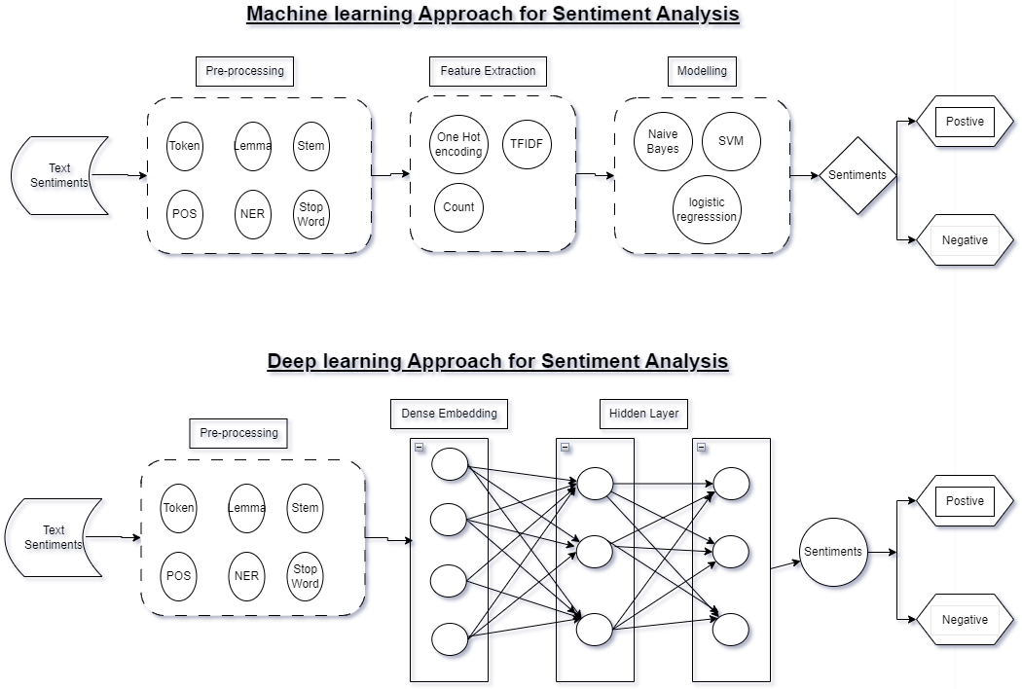

Figure A‑1: Sentiment Analysis

* + 1. Reinforcement Learning Framework

A Reinforcement Learning (RL) framework (brief architecture is displayed in 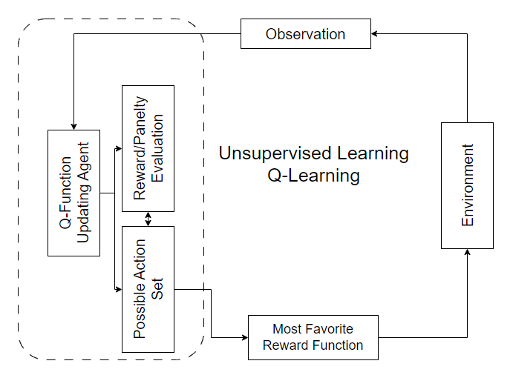

Figure A‑2: Unsupervised Learning (Reinforcement Learning)) will be developed to model the decision-making process in stock trading based on the sentiment analysis results. RL algorithms combined with Deep Neural network (LSTM) in Figure A‑3: LSTM Network (in conjunction with RL architecture in Figure 2) will be employed to learn optimal trading strategies by interacting with the market environment and maximizing a defined reward function.



Figure A‑2: Unsupervised Learning (Reinforcement Learning)



Figure A‑3: LSTM Network (in conjunction with RL architecture in Figure 2)

* + 1. Model Evaluation

For evaluating the proposed NLP and DRL model combining historical market data and texts to generate the insight, it is important to capture the sentiment of the text correctly and corelate it with the historic price data. In order to check the effectiveness of such a model, several performance metrics such as Accuracy, Precision, Recall (Sensitivity), F1-Score can be considered.

Since the aim of this study is also to improve the trading decision and reduce the possible losses and hence some of the financial metrics may also be used to check the performance of the prediction. Some of the such business metrics are listed below with a brief explanation.

* Cumulative Returns: Cumulative returns measure the total returns generated by the investment strategy over a specified period.
* Sharpe Ratio: The Sharpe ratio measures the risk-adjusted return of an investment strategy.

These metrics shall provide a comprehensive evaluation of the model's predictive power, profitability, and risk-adjusted performance.

The findings of the model will be interpreted to identify patterns and correlations between sentiment and price moves. Visualizations, statistical analysis, and qualitative assessments will be used to gain insights into the impact of sentiment on stock prices and financial market dynamics. Various graph depicting superimposition of real price move v/s predicted price moves shall provide a better mean of deciphering the results and make a profitable strategy.

* + 1. Limitations

Potential limitations of the research methodology include constraints on data availability, the inherent uncertainty and volatility of financial markets, and simplifying assumptions made in the model.

###### Expected Outcome

The proposed study aims to leverage NLP to extract the sentiment from the tweets relevant to the market movement. The application of LSTM with reinforcement learning will enable identification of the patterns and corelation within stock data enhancing the predictive capabilities of the model. The expected outcome of this study is to assist in developing an investment decision making system/signal for stock market by amalgamating state-of-the-art techniques from DRL and SA, thereby providing the individual investor, traders and market practitioners with more accurate and reliable tool for making informed decision in the dynamic market condition.

###### Required Resources

* + 1. Hardware Resources

Processor: Intel(R) Core (TM) i5-9300H CPU @ 2.40GHz (or equivalent)

RAM: 8GB

Graphics: Based on the requirements an external GPU can be used

Storage: SSD preferred for faster data access

OS: Windows 10, macOS, or Linux

* + 1. Software and Tools

Programming Language: Python 3.7 as it has a support for most of the latest ml algo

Libraries and Framework: TensorFlow, Pytorch, Keras

Data Visualization Tools: Matplotlib, Tableau

* + 1. Textual Data Processing Tools

Preprocessing textual data: NLTK (Natural Language Toolkit), Spacy

Web Scrapping: Beautiful Soup

Text processing and analysis: spacy

* + 1. IDE – interactive development environment

Jupyter Notebook IDE (based on requirements free GPU resources can be used)

VS-Code

###### Research Plan

Research project plan from Dec-2023 to May-2024 has been listed Figure A‑4: Research Project Plan. This will be further granularized as the program proceeds. It is using a scaling of 3 days so a plan duration of 6 means ~18 to ~19 days of effort.

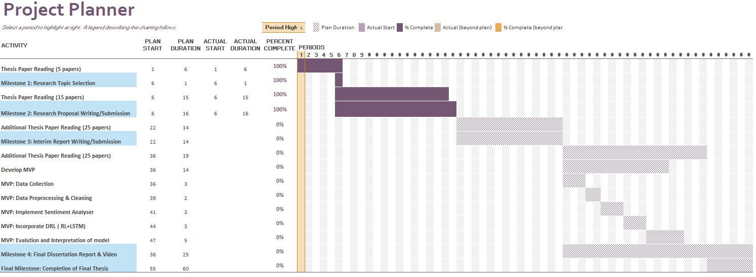

Figure A‑4: Research Project Plan

###### Risk and Contingency Plan

Table A‑3: Risk and Contingency Plan

|  |  |  |
| --- | --- | --- |
| **S#** | **Possible Risk** | **Contingency Plan** |
| **1** | Impact on the Research plan timelines due to some professional commitments or responsibilities. | It is possible and at times it is unavoidable however research plan proposed above provisions some buffer. |
| **2** | Quality of the thesis is not up to the mark. | Regular catchup with Thesis Supervisor can help get the timely feedback on the improvement of the quality of thesis. |
| **3** | Given the outcome of the thesis is quite challenging i.e. combine SA with Deep-Q-Network, it is possible that it does not produce the expected outcome. | Meeting milestone as listed in the Research plan on time, putting a system of checks and balances, regular catchup with Thesis Supervisor should keep the Research on track and achieve the expected outcome. |
| **4** | Computational Resource challenges – training a large set of data using LSTM and RL may require significant computational resource and time. | Optimizing the model by hyperparameter tuning, train at small dataset instead of large datasets, consider using the cloud platform could be some of those options that can help mitigate this risk |